  - Caleb McBeth

Project Home Stash Documentation
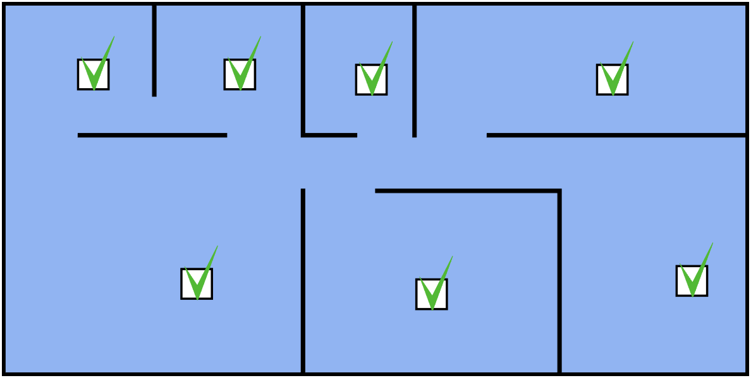
(Logo Created In https://tilda.cc/lp/vector/)

Executive Summary
Many individuals who own personal property have difficulty creating comprehensive documentation detailing their possessions. In minor situations, this can lead to frustration, missing items, or duplicate purchases. However, this lack of documentation can lead to more serious consequences in more serious cases, such as a fire, flood, or theft. In situations like this, thorough documentation is needed to properly and quickly generate an inventory for insurance claims and the protection of the lost goods. Without a dedicated and centralized documentation tool, the process of collecting information and generating an itemized home inventory will be difficult, frustrating, and prone to inaccuracies.
Project Home Stash is a desktop application designed to help users create and maintain a digital inventory of household items. The application allows users to record information such as item names, categories, locations within the home, estimated values, and optional notes. Additionally, a major component of the application is a top-down 2D view of the home that would provide a visual aid and serve as an interactive user interface, which provides the user with an intuitive sense of the location of each of the items within the physical area. By providing a centralized and visually intuitive tool, this project provides a practical solution to household inventory management.
Those individuals who desire to create a dynamic, centralized, and accurate account of their belongings are the target audience for this application. Specific examples are homeowners, renters, or building managers who want accurate tracking of their physical inventory. The primary goal of this project is the implementation of a desktop application that is visually user-friendly and creates an accurate home inventory that accounts for physical location.

Scenarios
These scenarios represent the various significant interactions the user would have with the application over the course of using it.

Scenario 1 | Program Start: Selecting The Current User
- The first interaction the user has with the system is at startup, where the following form is displayed.
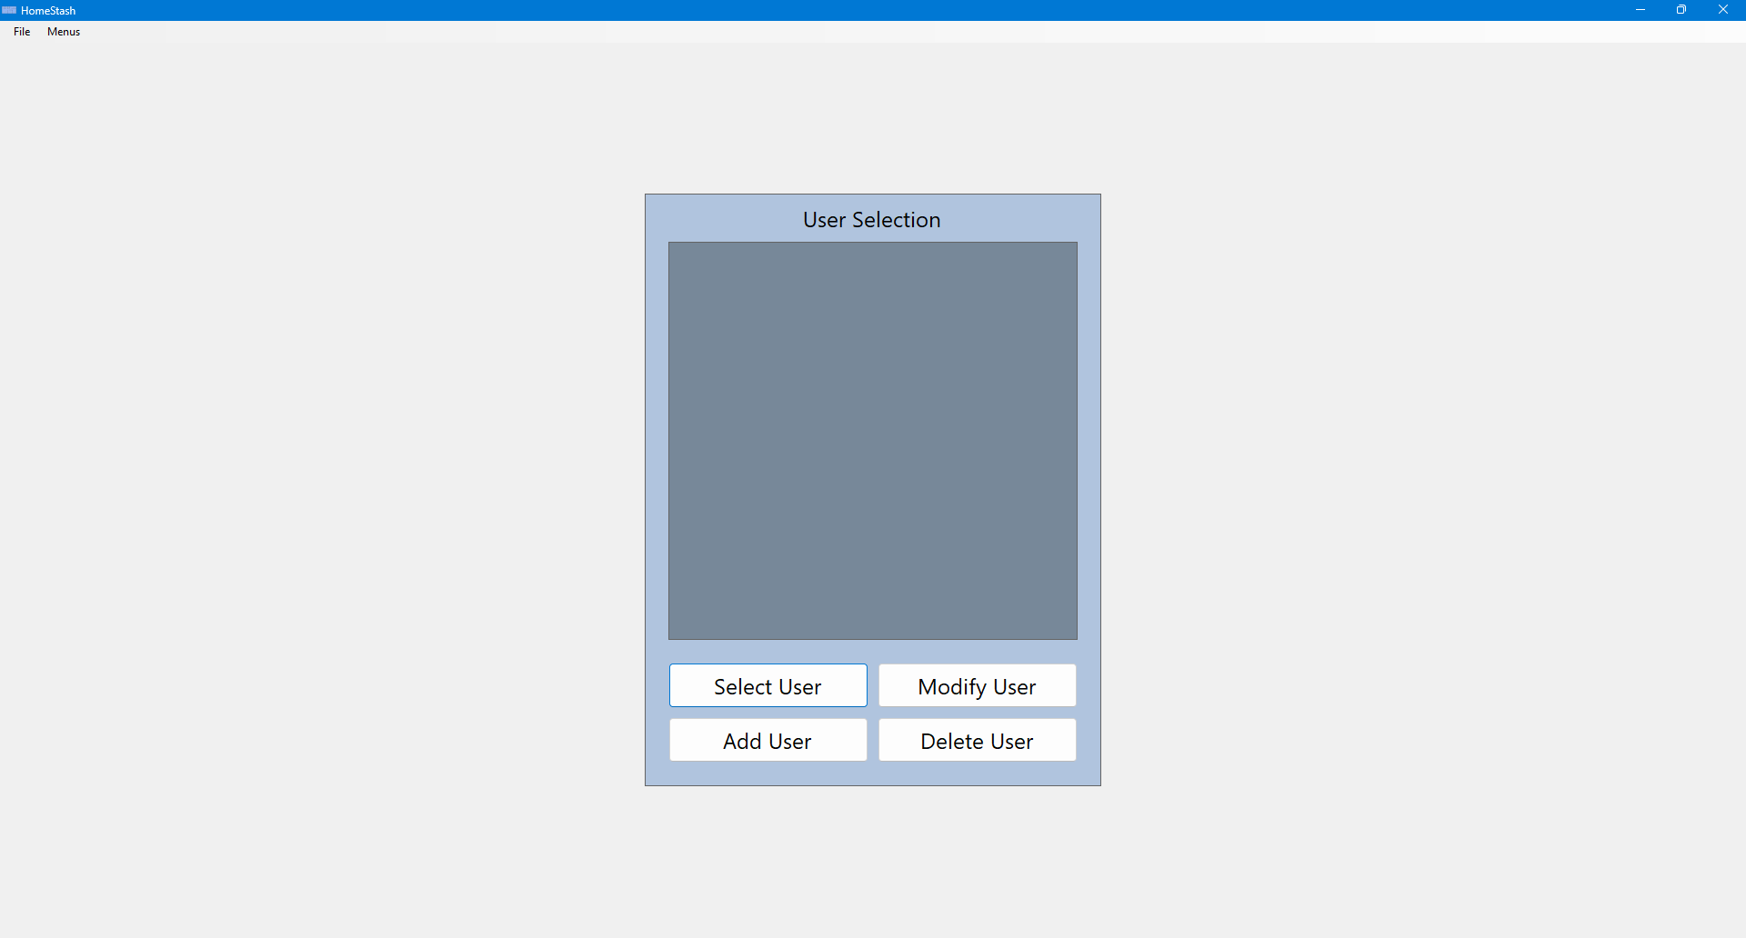
- If no user profiles currently exist, the user selects the “Add User” button, which opens the following form. If a user profile already exists, it will be displayed on this form, and the user may optionally proceed directly to Step 4.
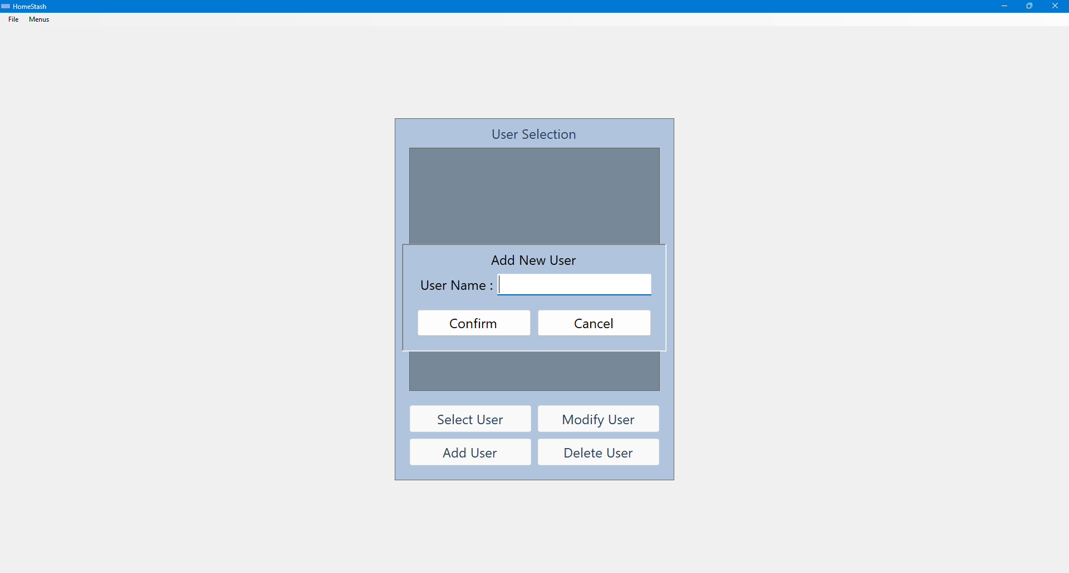
- The user enters the desired user name and selects the “Confirm” button. The system then validates the input and returns to the initial form, where the newly created user profile is now displayed in the selection list.
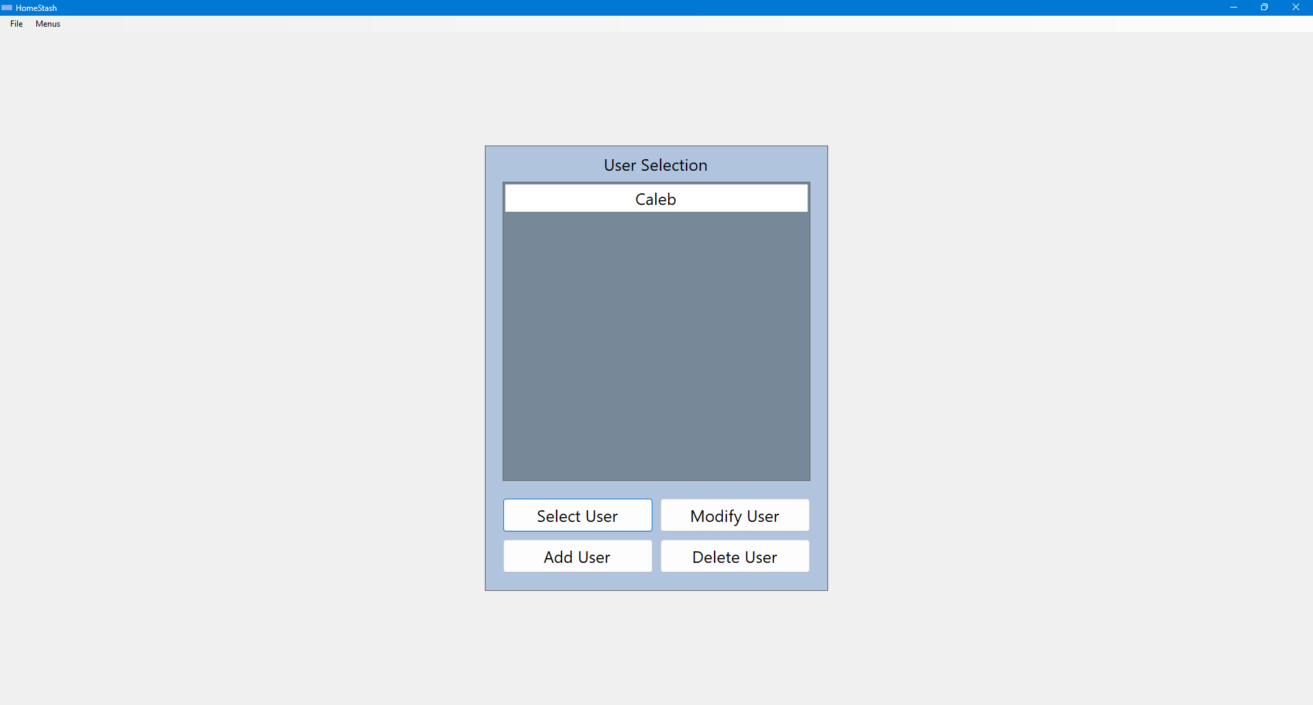
- The user selects a profile from the list and clicks the “Select User” button. The system then proceeds to the next form for building selection.
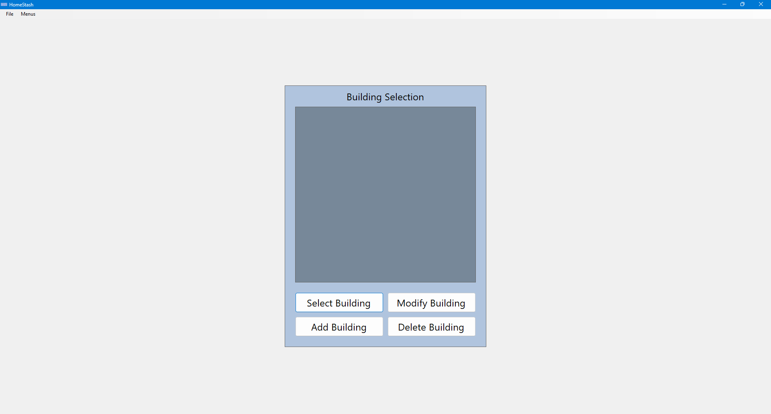

Scenario 2 | Selecting The Current Building
- Once a user profile has been selected (see Scenario 1), the following form is displayed.

- If no buildings currently exist for the selected user profile, the user selects the “Add Building” button, which opens the following form. If a building already exists, it will be displayed on this form, and the user may optionally proceed directly to Step 4.
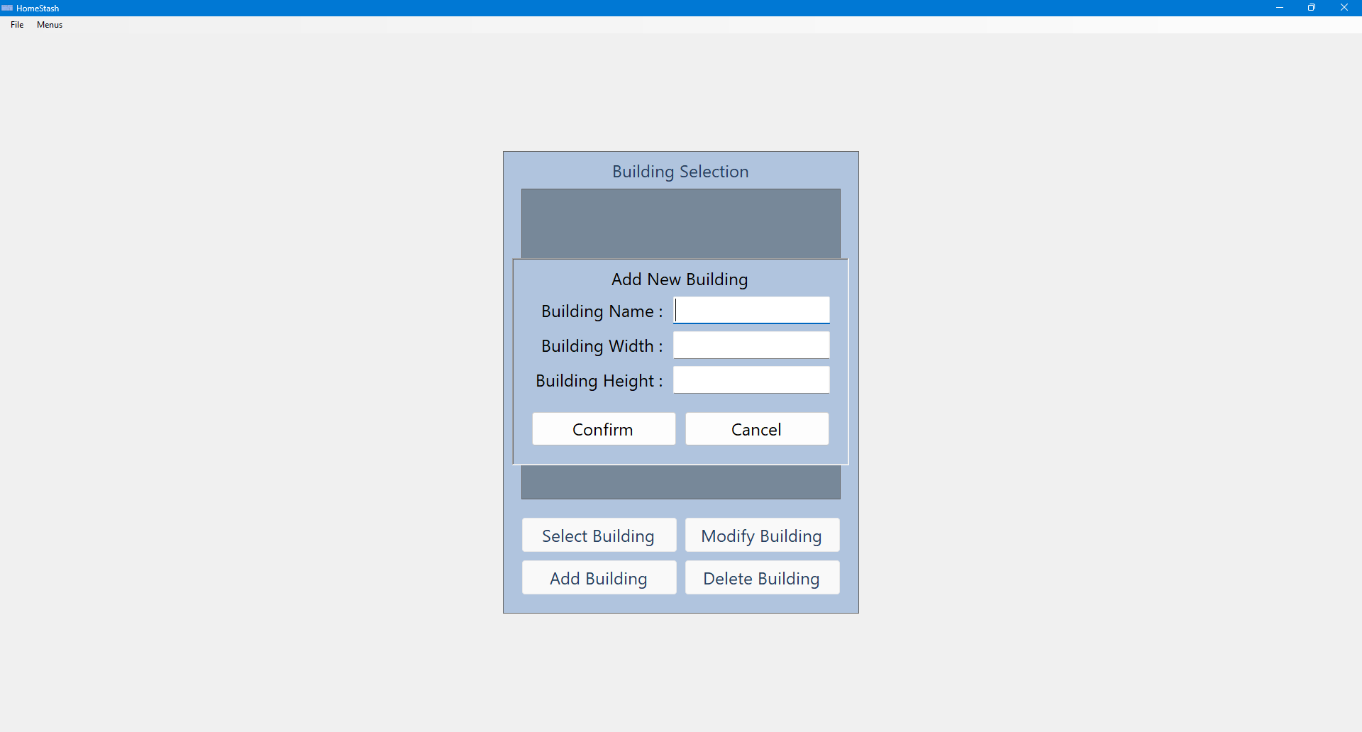
- The user enters the desired building information and selects the “Confirm” button. The system then validates the input and returns to the initial form, where the newly created building is now displayed in the selection list.
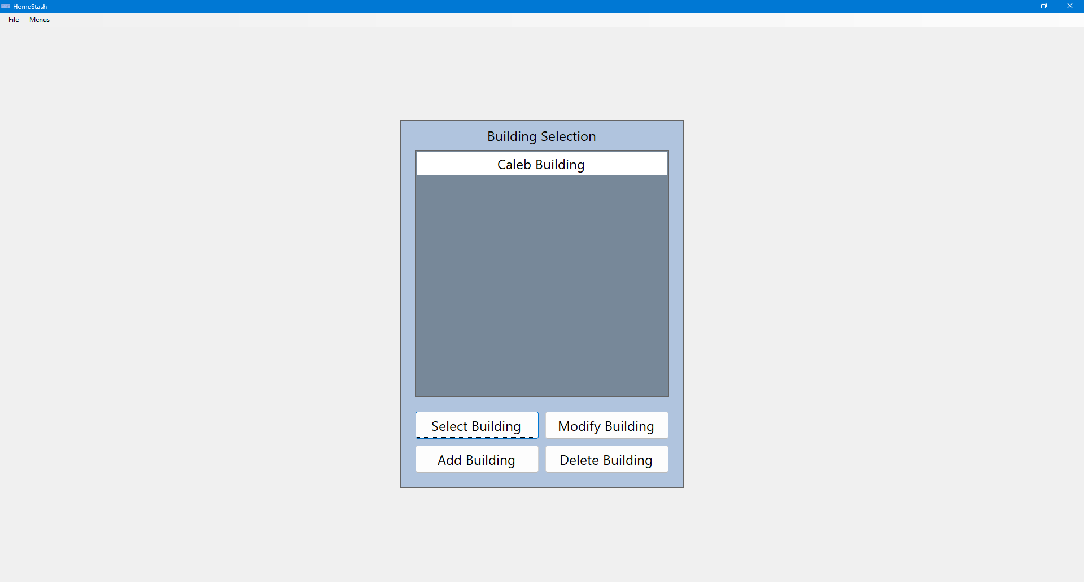
- The user selects a building from the list and clicks the “Select Building” button. The system then proceeds to the next screen for managing inventory for the building.
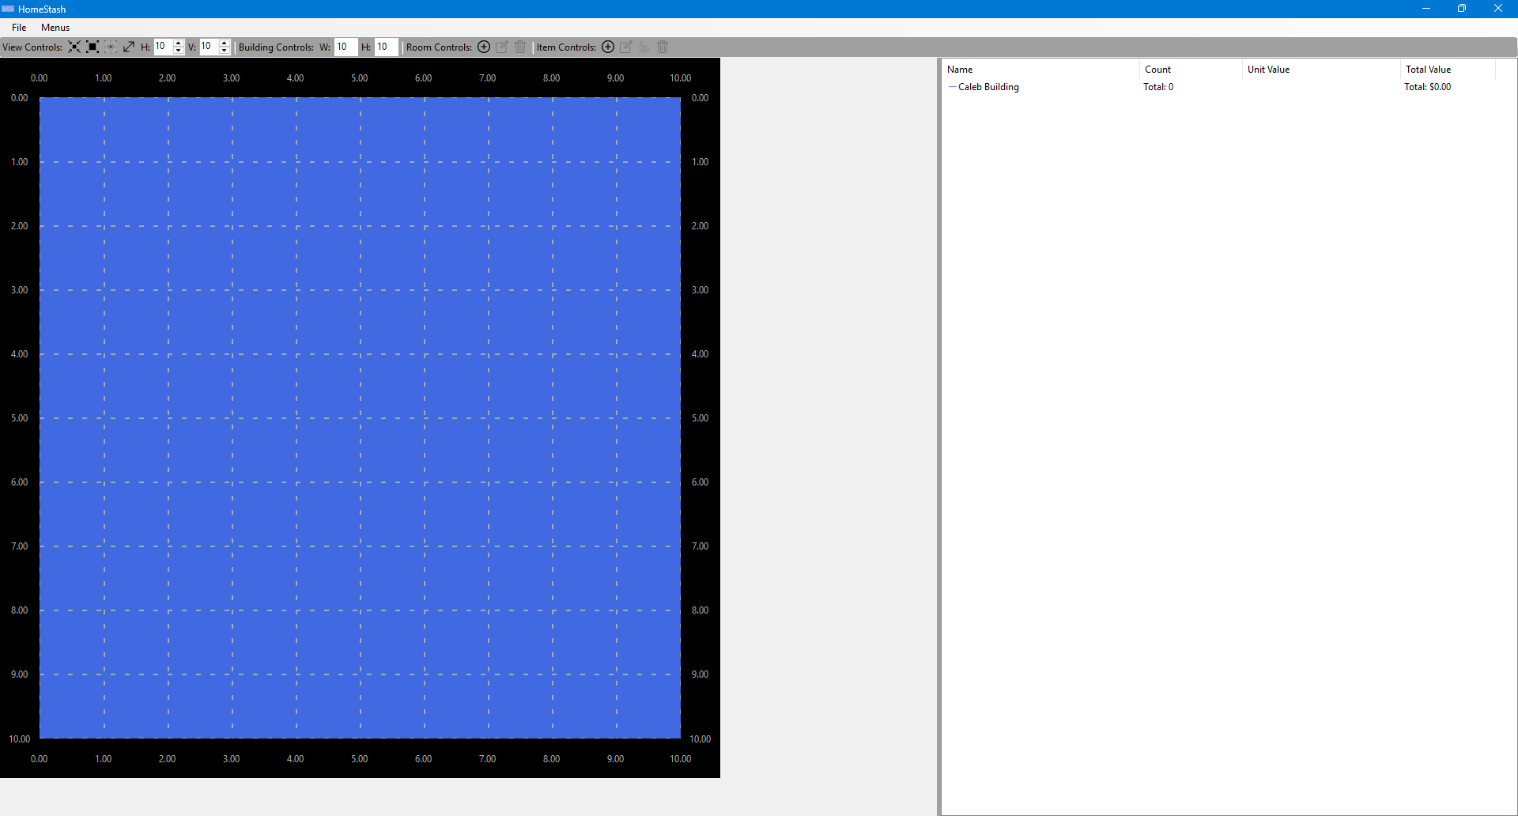

Scenario 3| Managing Building Rooms
- Once a building has been selected (see Scenario 2), the system displays the top-down building screen for the selected building. This screen provides a visual layout of the building with the rooms in it on the left-hand side, with a tree-list view of all the rooms and items on the right-hand side.

- From this screen, the user may select from several actions, including adding a new room, modifying an existing room, or deleting a room.
Adding A Room
- To add a new room, the user selects the add room toolstrip button in the “Room Controls” portion of the toolstrip. The system displays a form where the user can enter the desired room information.
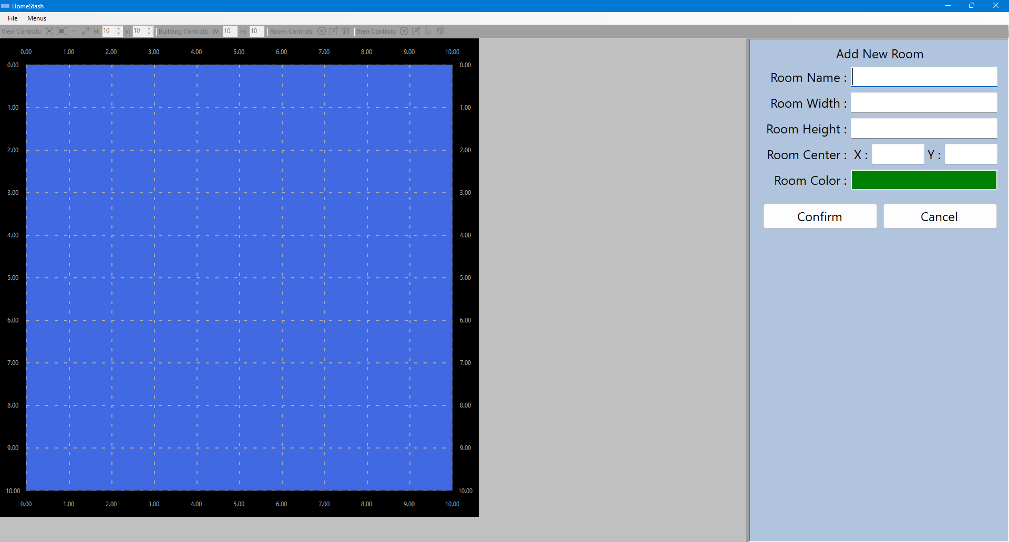
- The user enters the desired room information and selects the “Confirm” button. The system then validates the input and returns to the top-down building screen. The newly created room will be reflected in this screen.
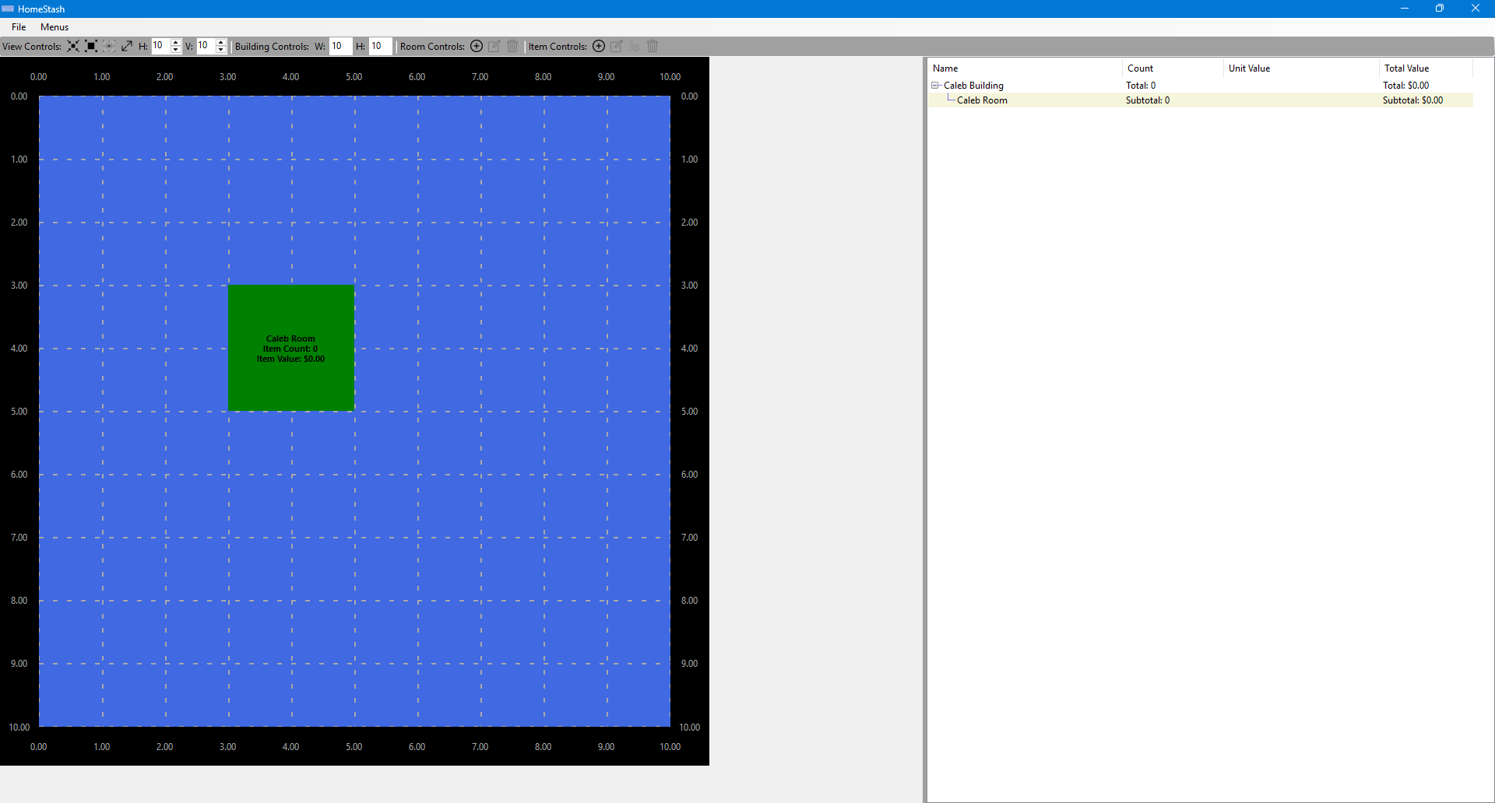
Modifying A Room

- To modify an existing room, the user clicks on the room they want to modify, and then clicks on the modify room toolstrip button in the “Room Controls” portion of the toolstrip. The system displays a form where the user can modify the desired room information.
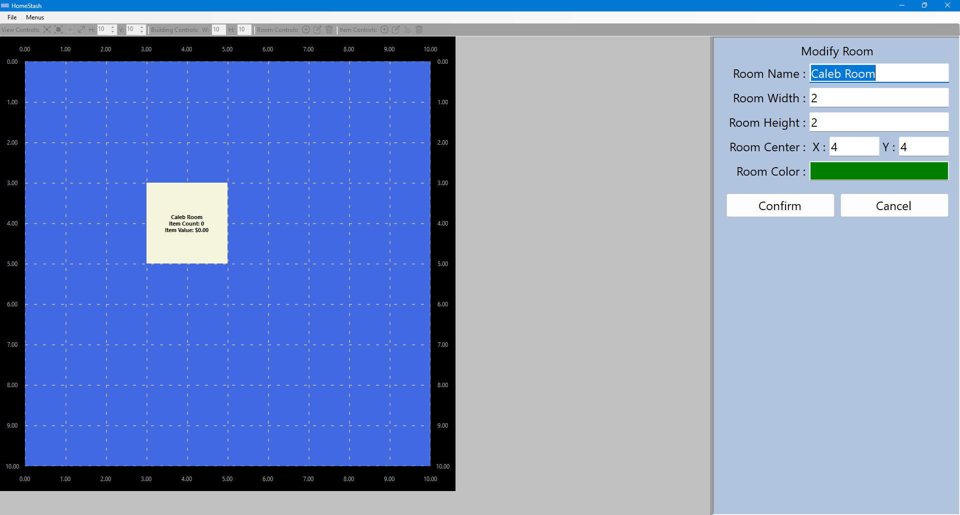
- The user enters the desired room information and selects the “Confirm” button. The system then validates the input and returns to the top-down building screen. The modified room will be reflected in this screen.
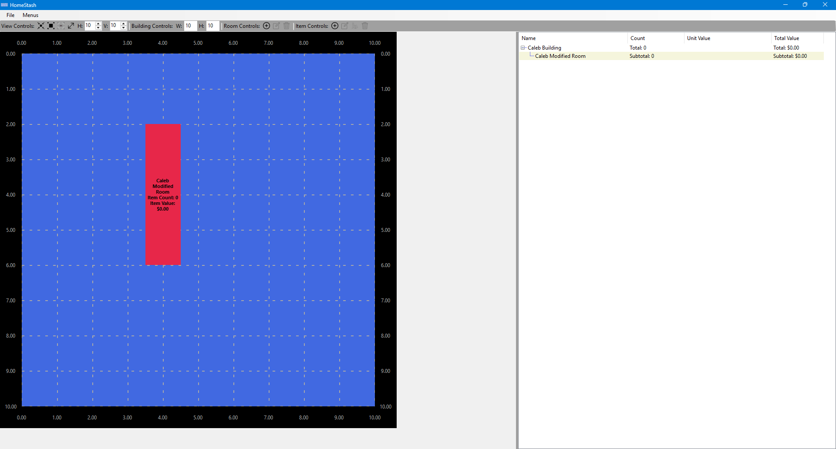
Deleting A Room
- To delete an existing room, the user clicks on the room they want to delete, and then clicks on the delete room toolstrip button in the “Room Controls” portion of the toolstrip. The system will remove the room and all of its items.
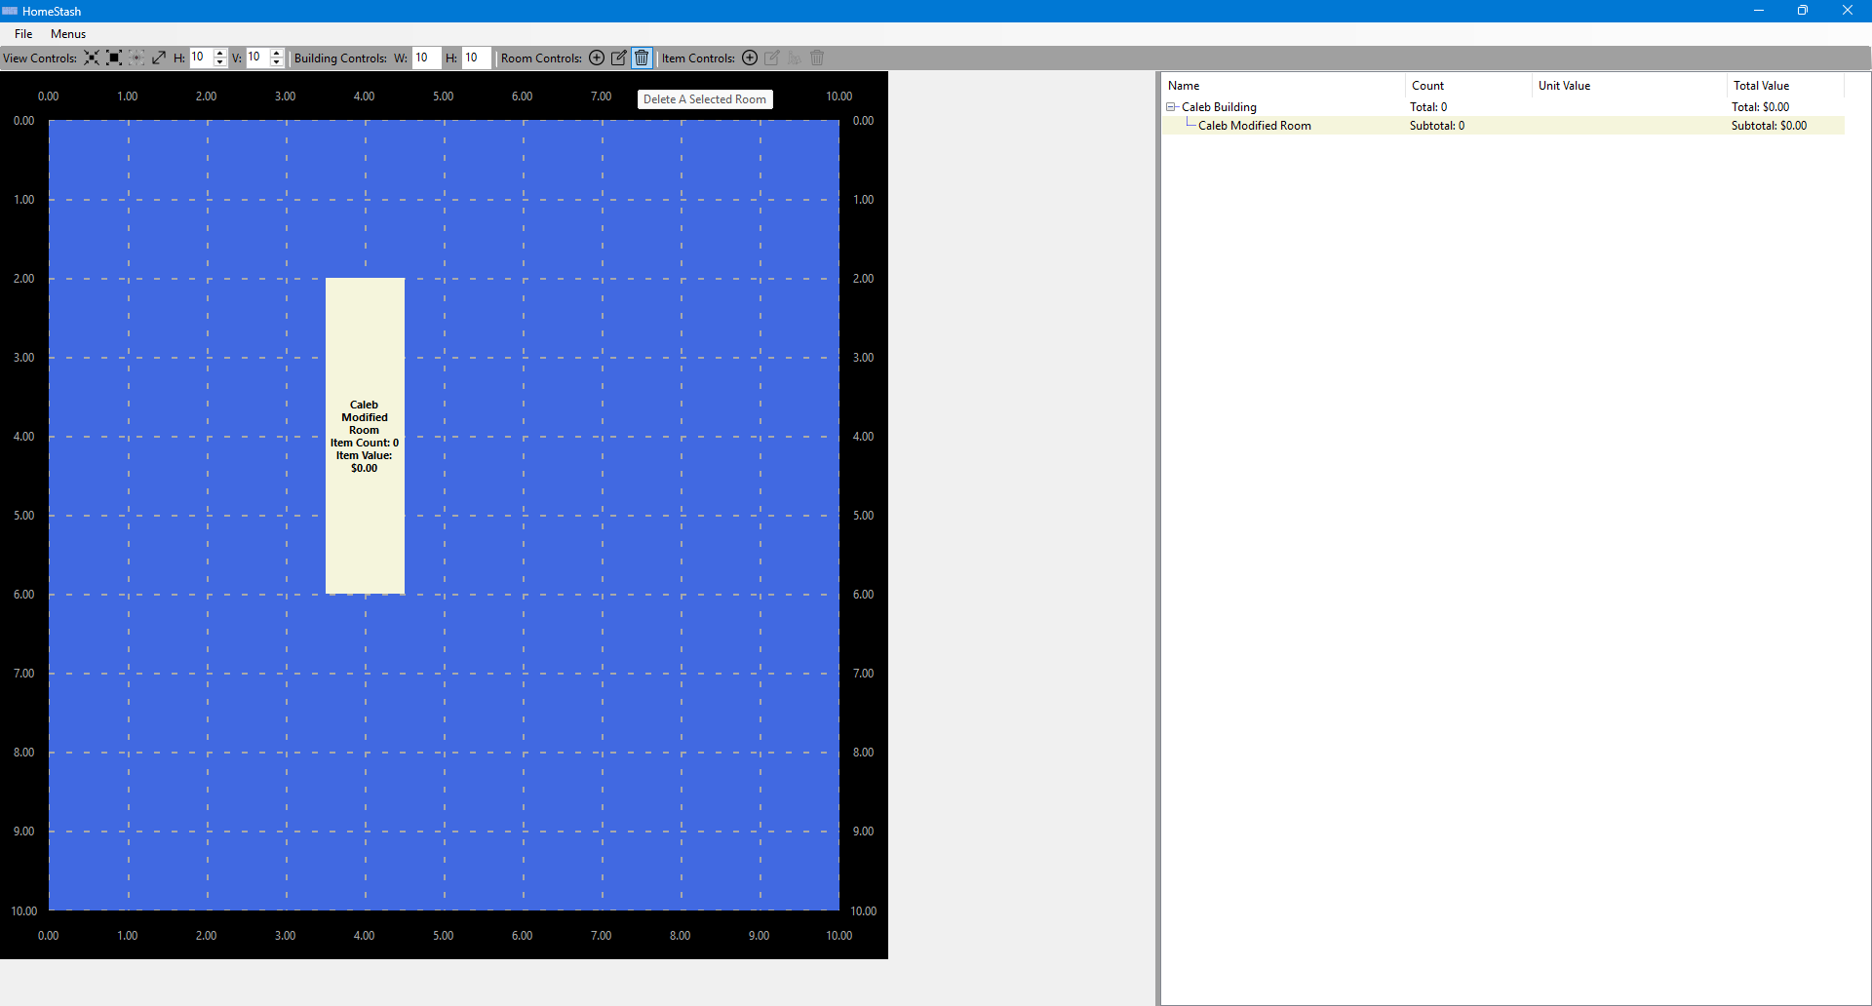
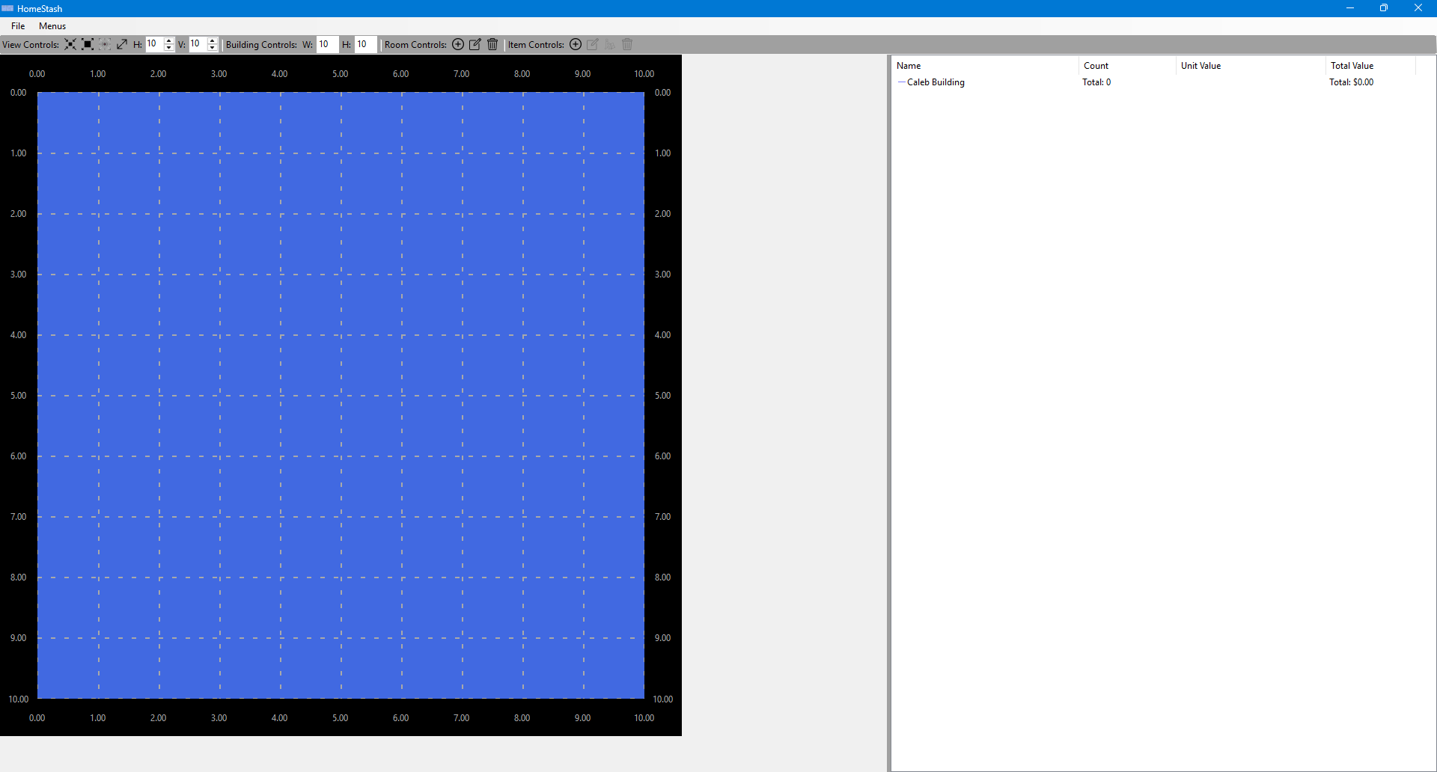

Scenario 4| Managing Building Items
- Once a building has been selected (see Scenario 2), the system displays the top-down building screen for the selected building. This screen provides a visual layout of the building with the rooms in it on the left-hand side, with a tree-list view of all the rooms and items on the right-hand side.

- From this screen, the user may select from several actions, including adding a new item, modifying an existing item, moving an item, or deleting an item.
Adding An Item
- To add a new item, the user selects the add item toolstrip button in the “Item Controls” portion of the toolstrip. The system displays a form where the user can enter the desired item information.
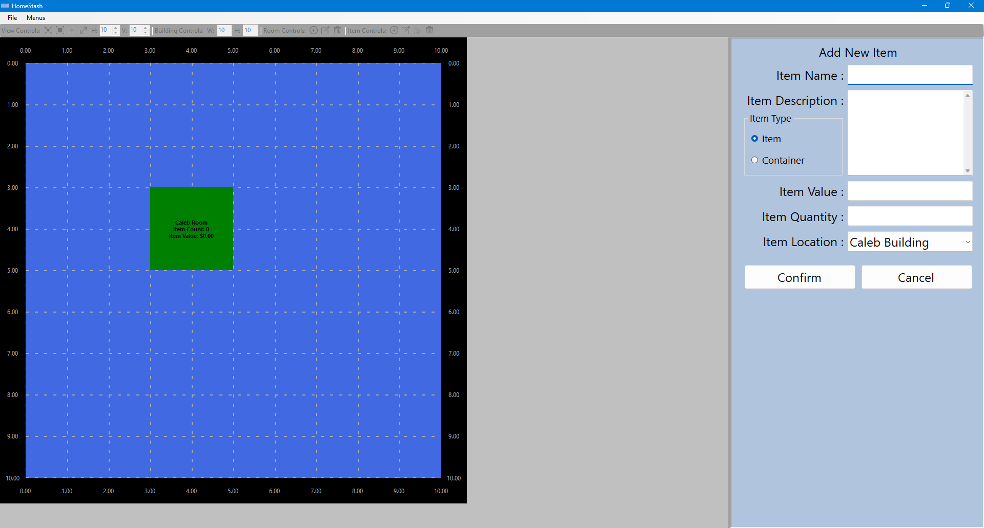
- The user enters the desired item information and selects the “Confirm” button. The system then validates the input and returns to the top-down building screen. The newly created item will be reflected in this screen.
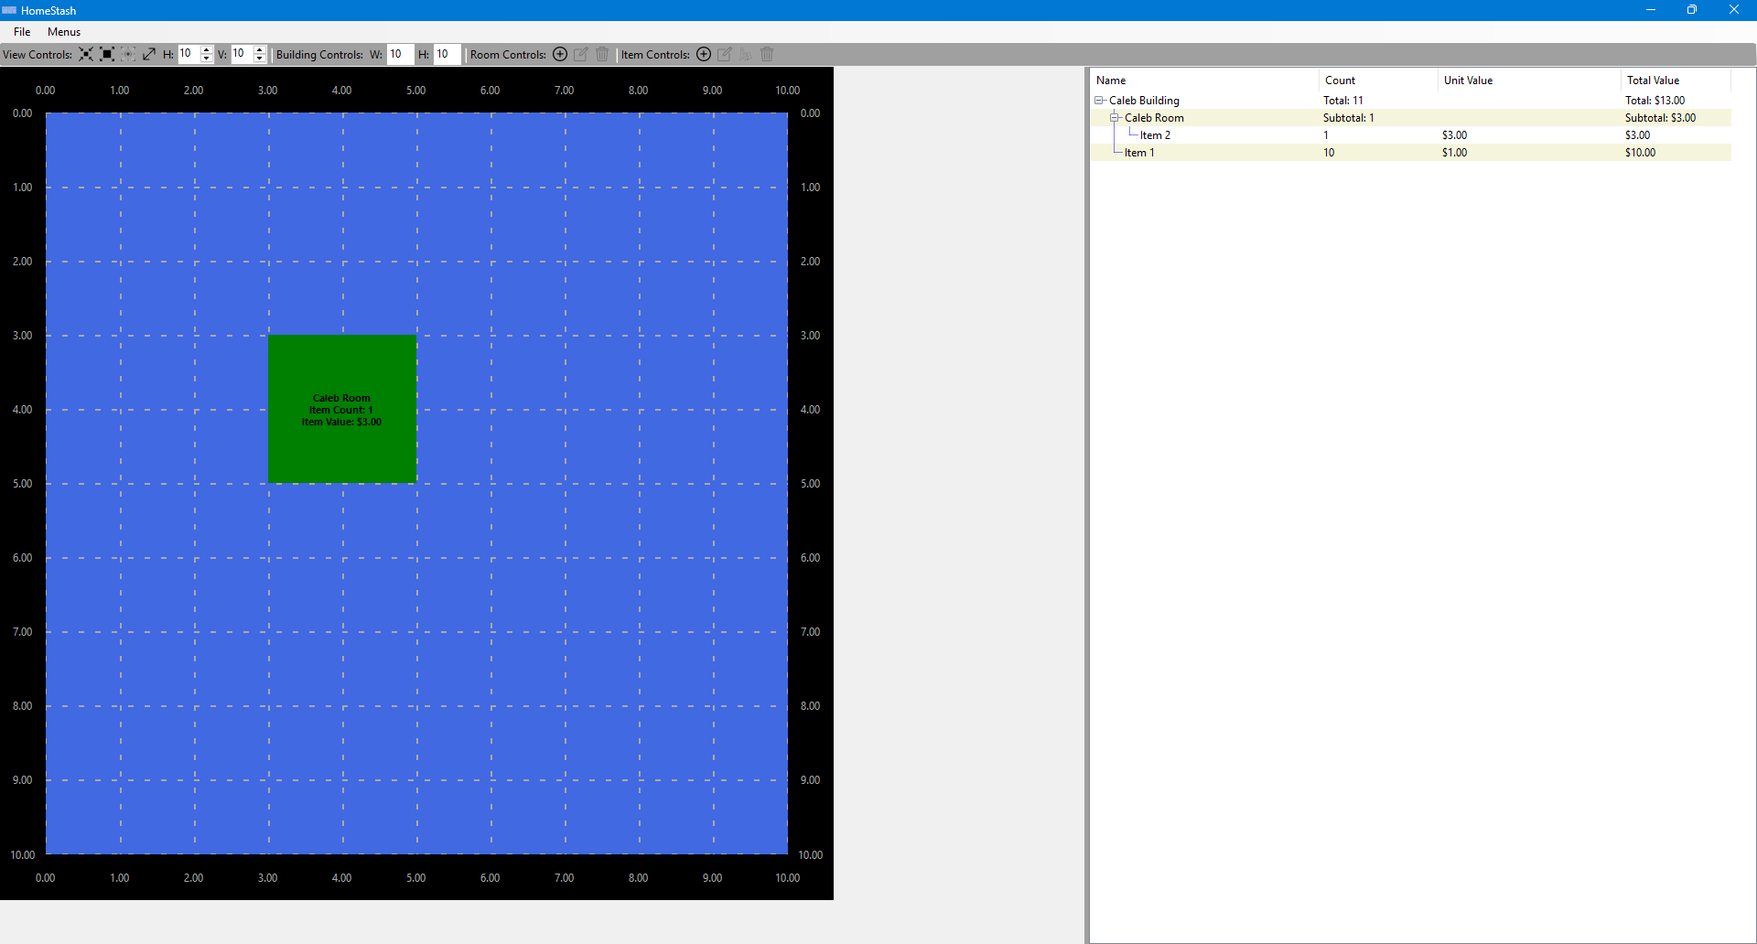
Modifying An Item

- To modify an existing item, the user clicks on the item they want to modify, and then clicks on the modify item toolstrip button in the “Item Controls” portion of the toolstrip. The system displays a form where the user can modify the desired item information.
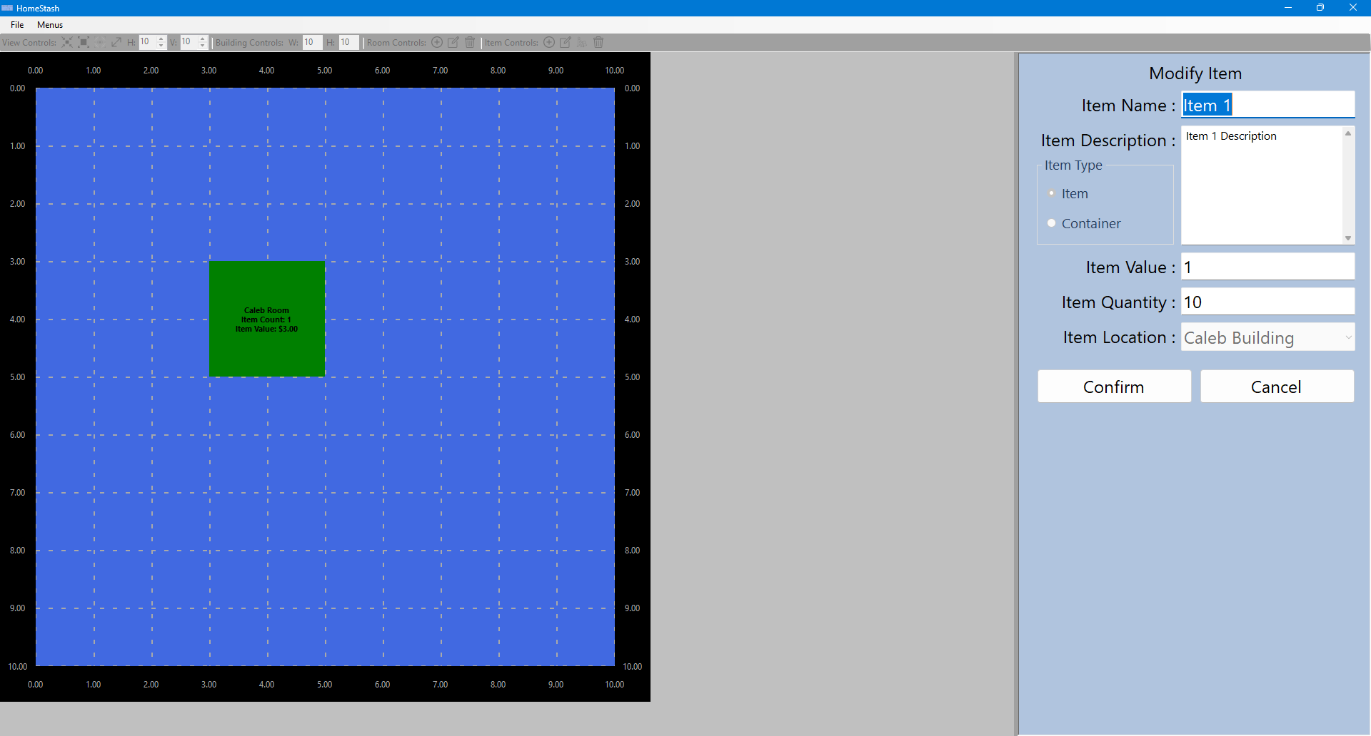
- The user enters the desired item information and selects the “Confirm” button. The system then validates the input and returns to the top-down building screen. The modified item will be reflected in this screen.
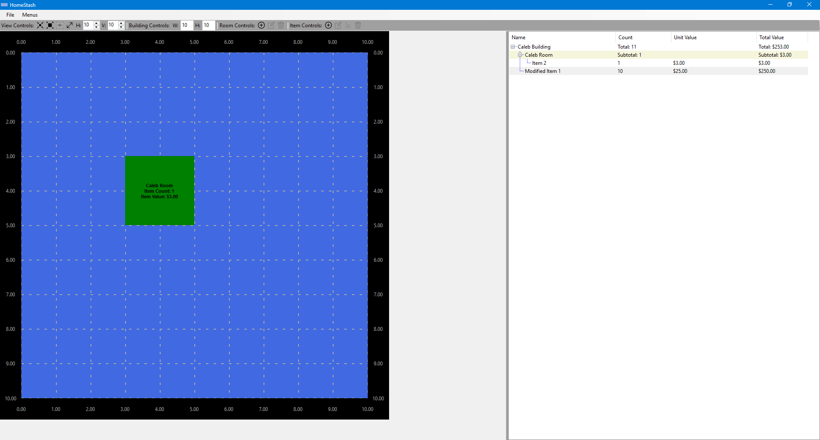
Moving An Item
- To move an existing item, the user clicks on the item they want to modify, and then clicks on the move item toolstrip button in the “Item Controls” portion of the toolstrip. The system displays a form where the user can move the desired item to a new location.
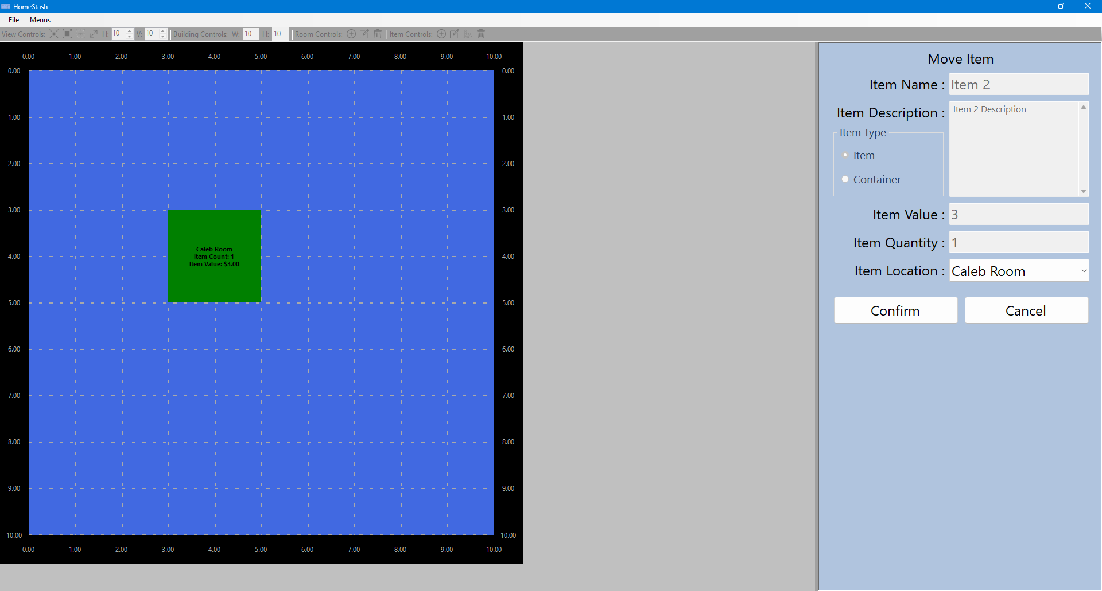
- The user changes the location for the selected item and clicks the “Confirm” button. The system then validates the input and returns to the top-down building screen. The moved item will be reflected in this screen.
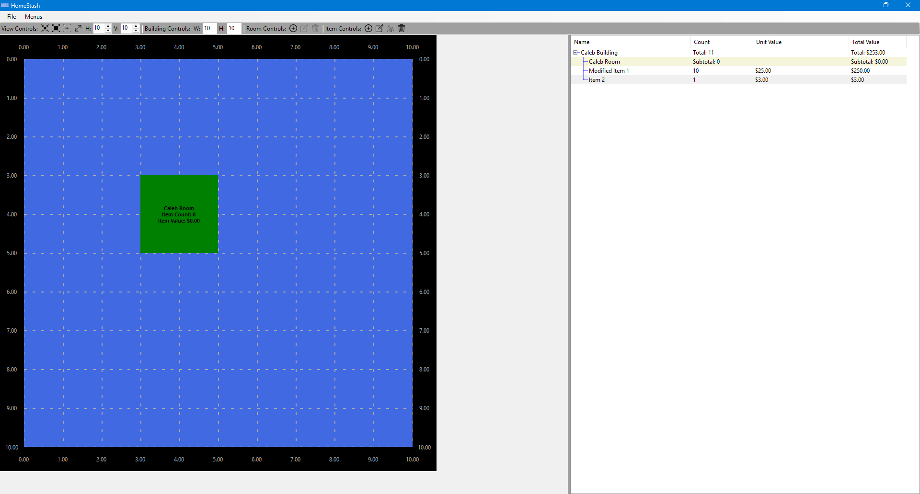
Deleting An Item
- To delete an existing item, the user clicks on the item they want to delete, and then clicks on the delete item toolstrip button in the “Item Controls” portion of the toolstrip. The system will remove the item and all of its children.
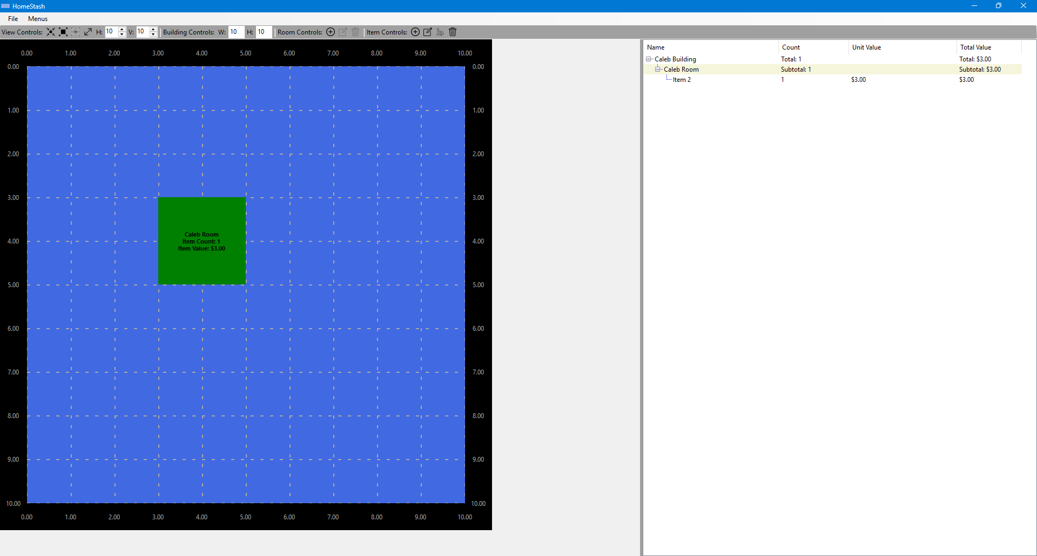

Scenario 5| Navigating Between Forms And Screens
This scenario demonstrates how the user can navigate between the top-down building screen, the building selection form, and the user selection form using the menus at the top of the screen.
- From the top-down building screen, the user selects the “Menus” dropdown at the top of the screen and selects “Building Selection”.
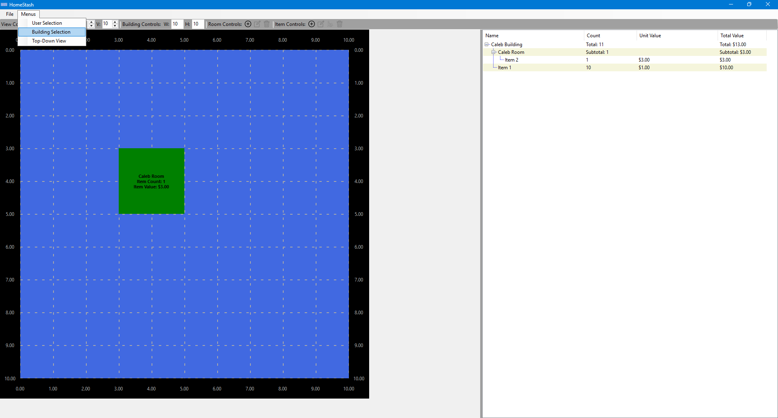
- The system displays the building selection form.
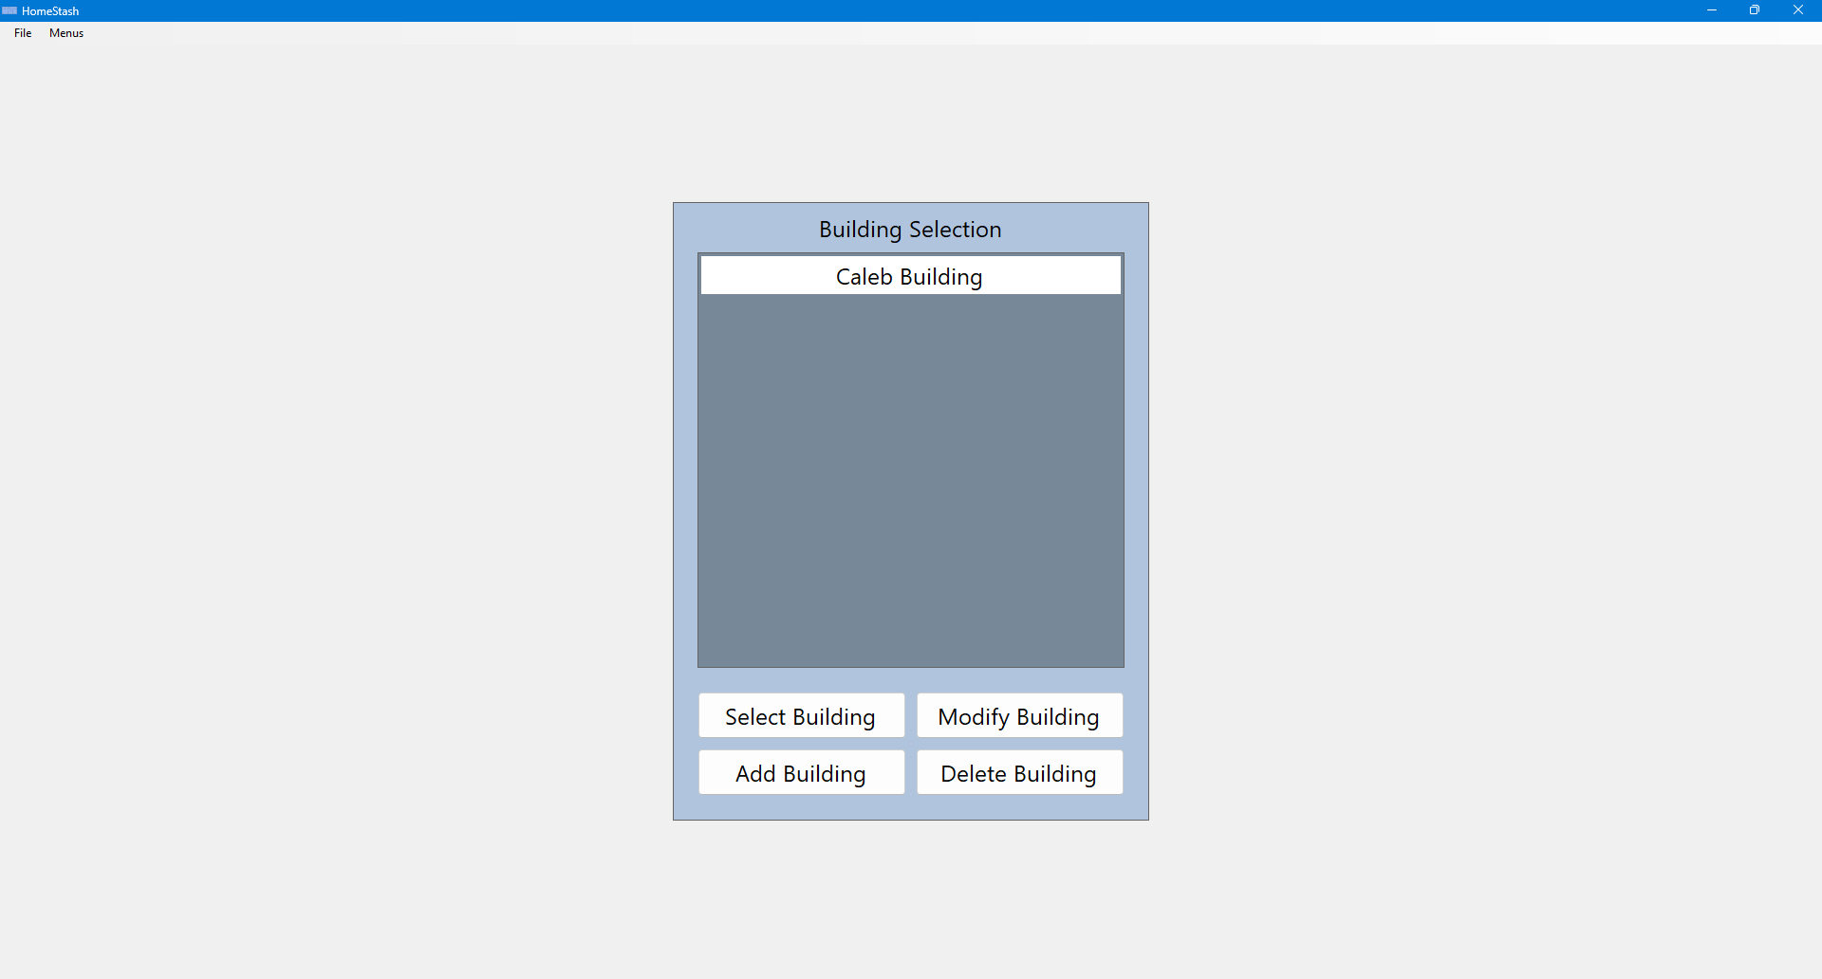
- From the building selection form, the user selects the “Menus” dropdown at the top of the screen and selects “User Selection”.
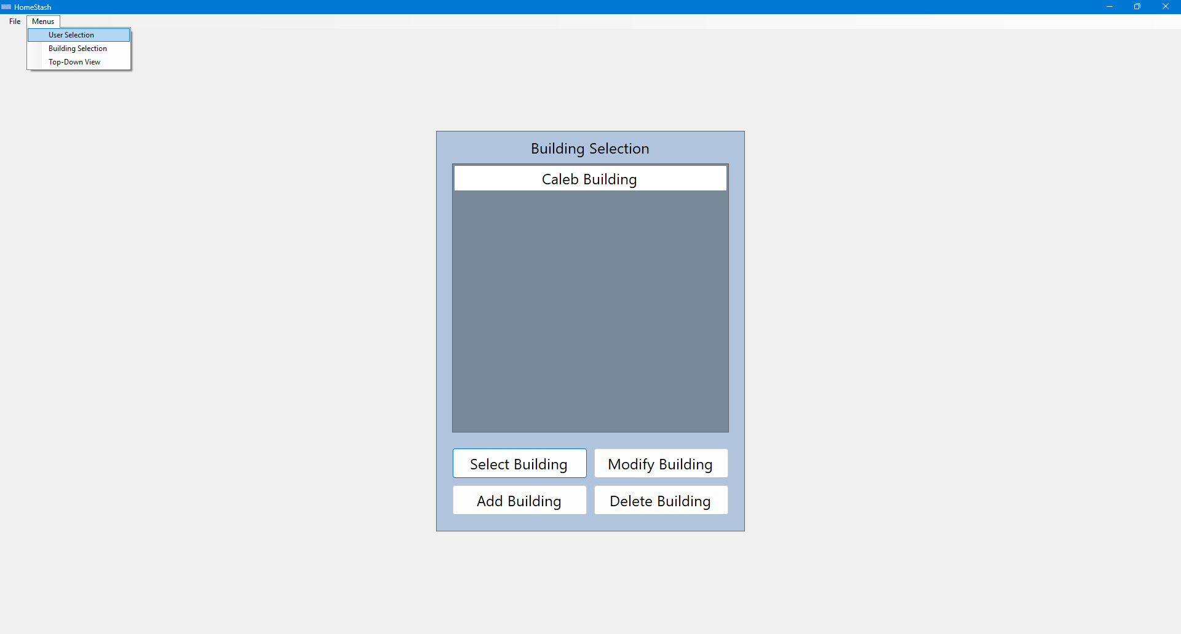
- The system displays the user selection form.
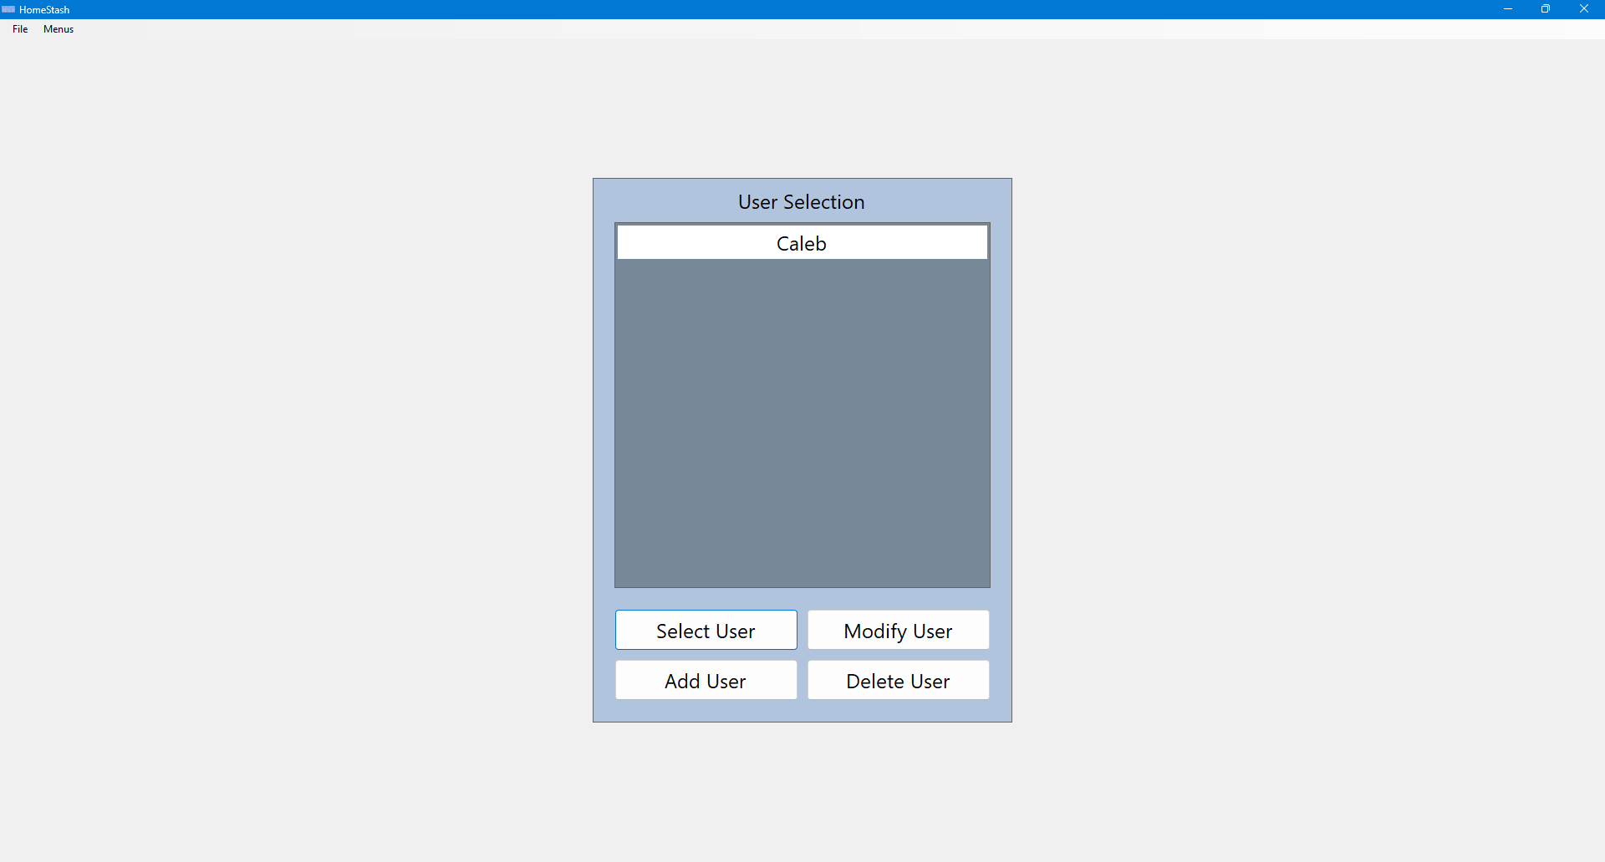
- From the user selection form, the user selects the “Menus” dropdown at the top of the screen and selects “Top-Down View”.
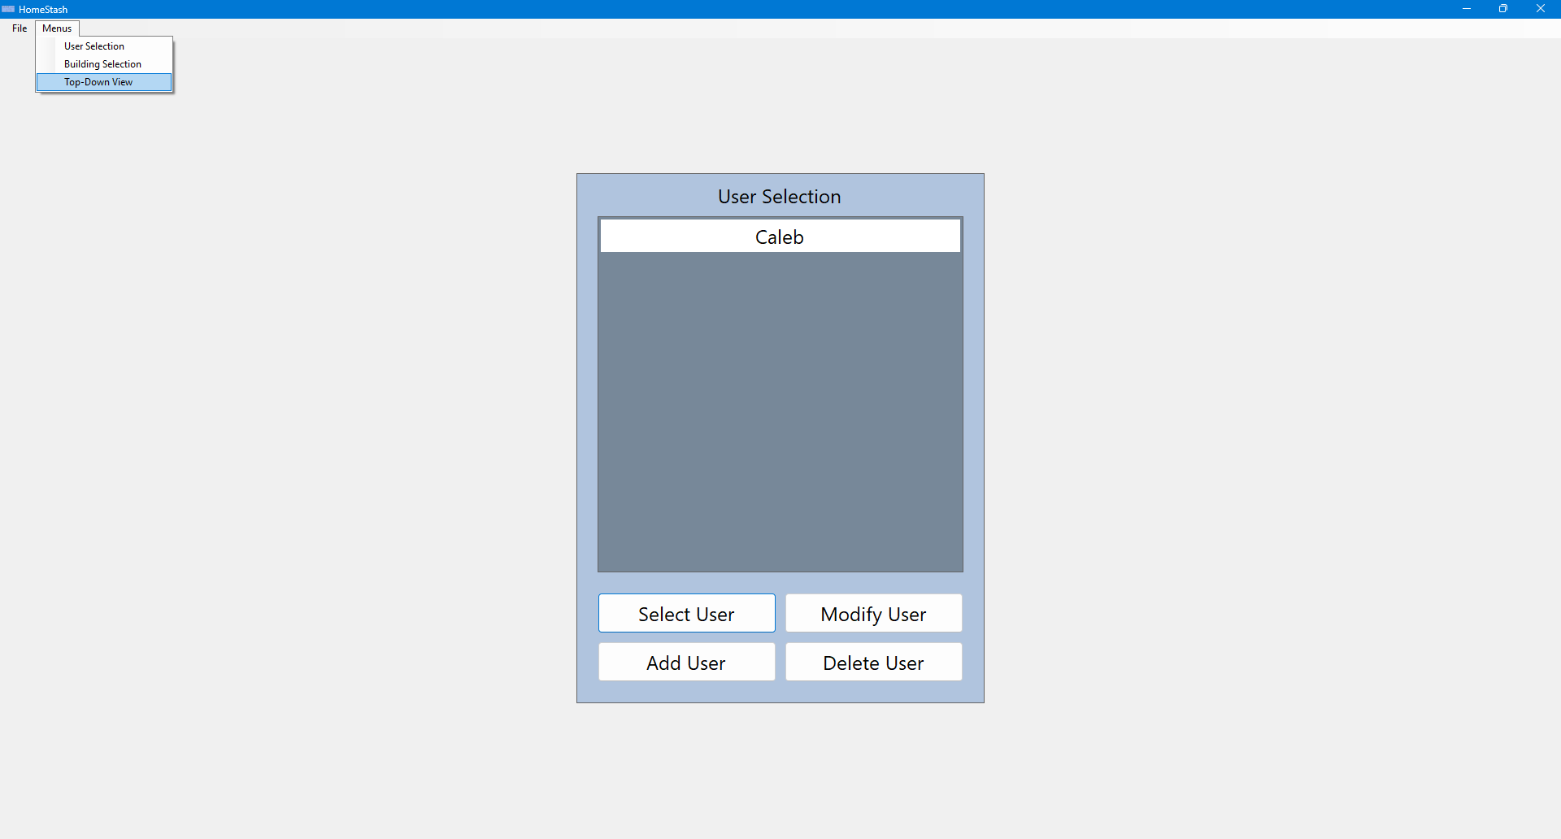
- The system displays the top-down building screen.
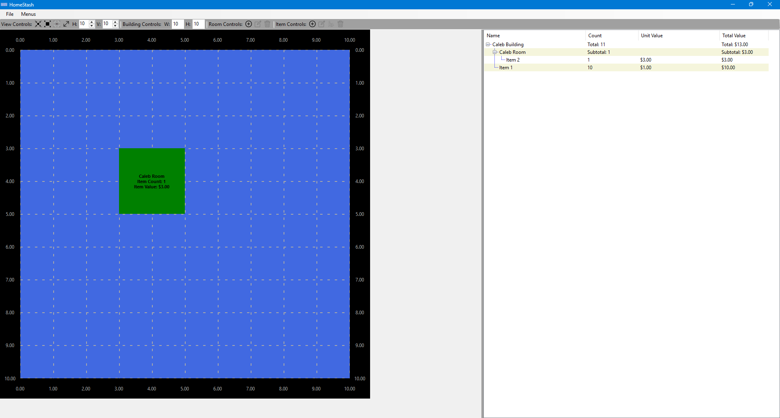

Scenario 6| Saving Changes To Long-Term Storage
- After making changes within the program, the user selects the “File” dropdown at the top of the screen and selects “Save”. This commits the current state of the program to long-term storage.
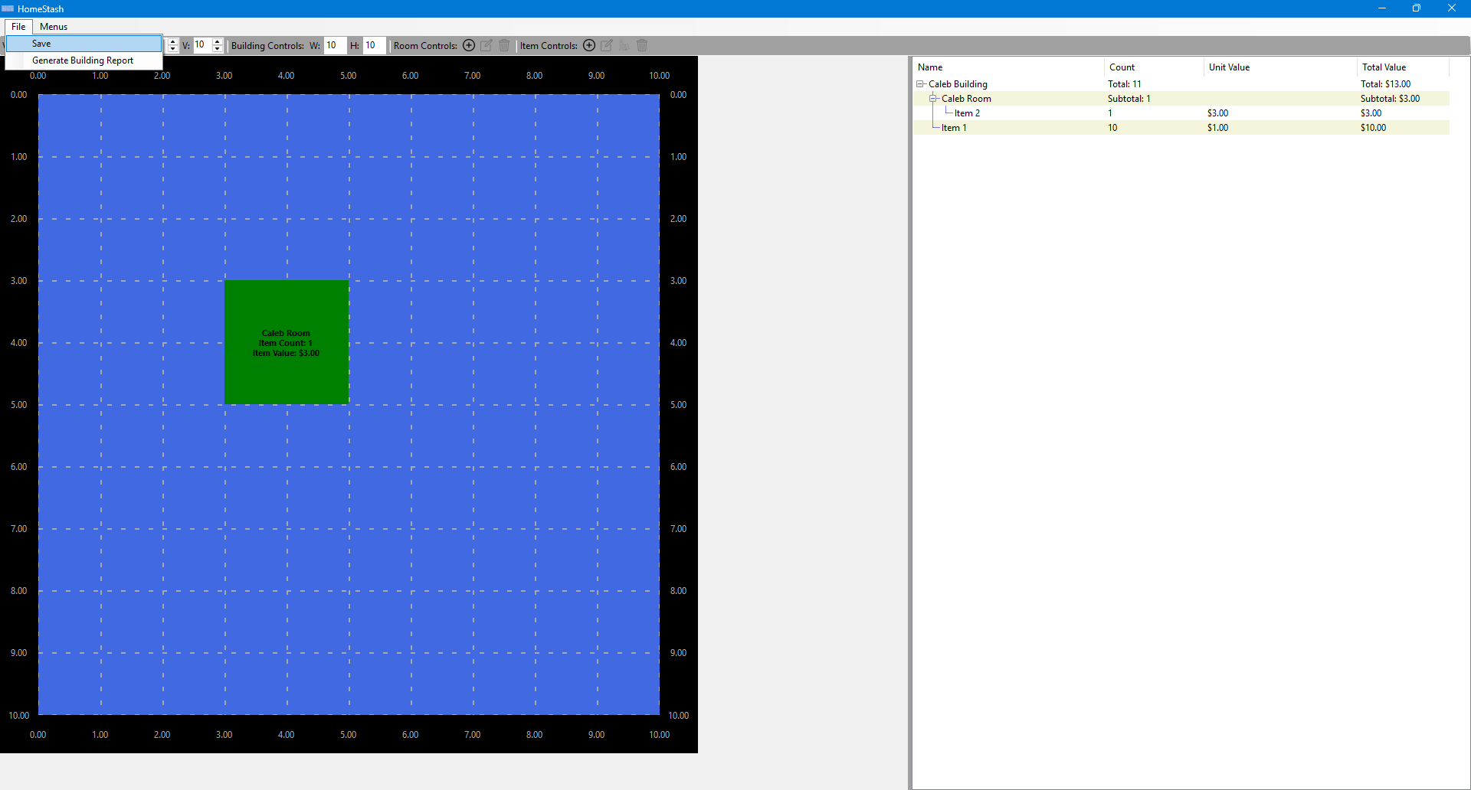

Scenario 7| Generating A Report
- From the top-down building screen, the user selects the “File” dropdown at the top of the screen and selects “Generate Building Report”.
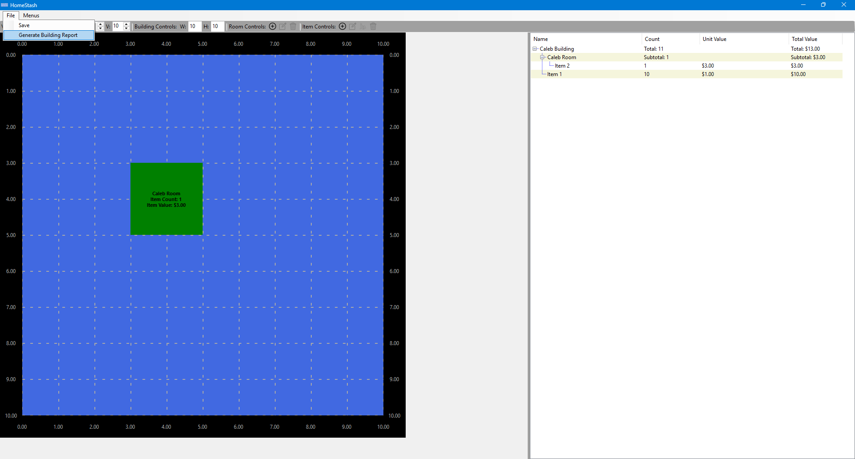
- The user specifies the desired name for the report and the location it will be saved to.
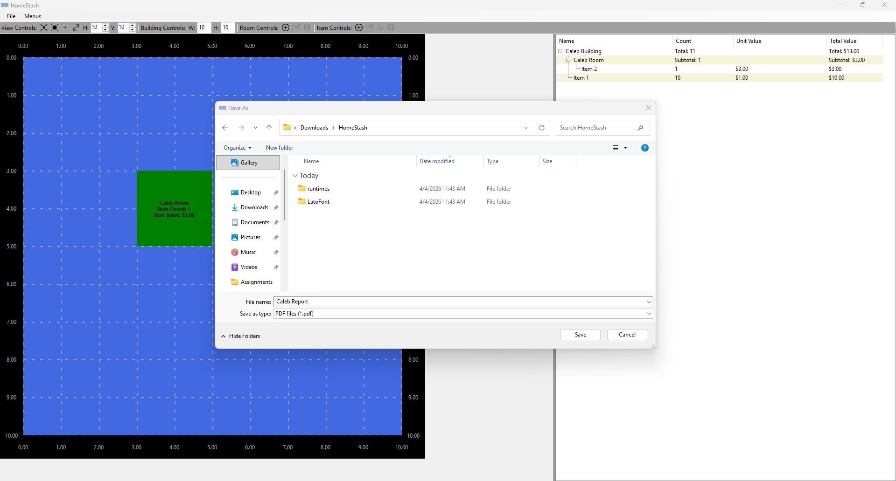
- The user clicks save, and the report is saved as a PDF in the location specified. Opening the report shows the following document.
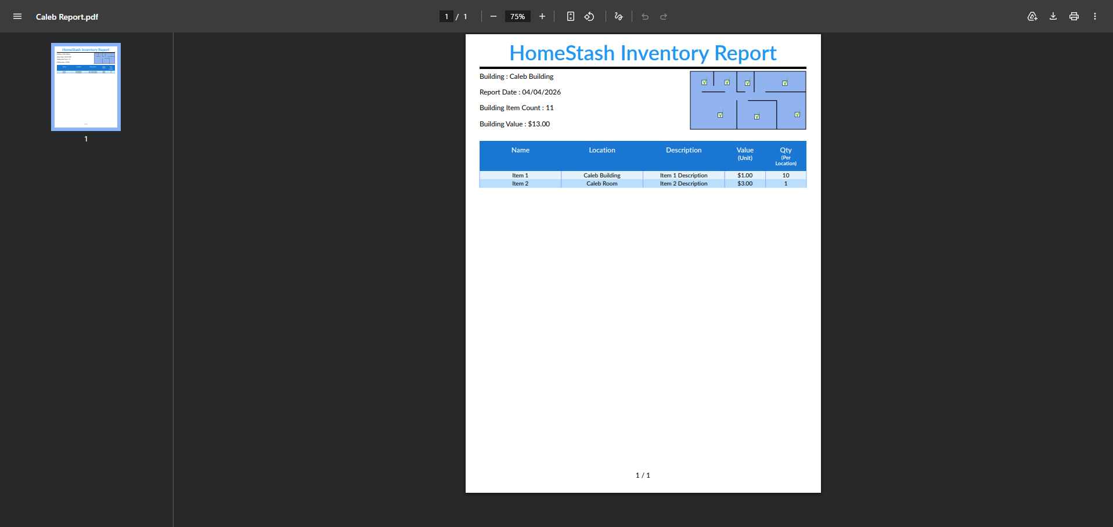

Reports
The current reporting features of Project Home Stash allow users to generate a Building Inventory Report in PDF format. This report contains an itemized list of all items stored within a specific building.

Building Inventory Report
Purpose: Provides a complete itemized list of each item stored within the building.
Contents:
- Header with summary information, including the building the report is attached to, the report date, the total item count, and the total item value.
- Content section with each row representing an item. Each row contains the item’s name, location, description, unit value, and quantity per location.
Output Format: PDF
How to Generate: From the top-down building screen, select File > Generate Building Report, and specify the report name and save location, then click Save.


Screenshot:
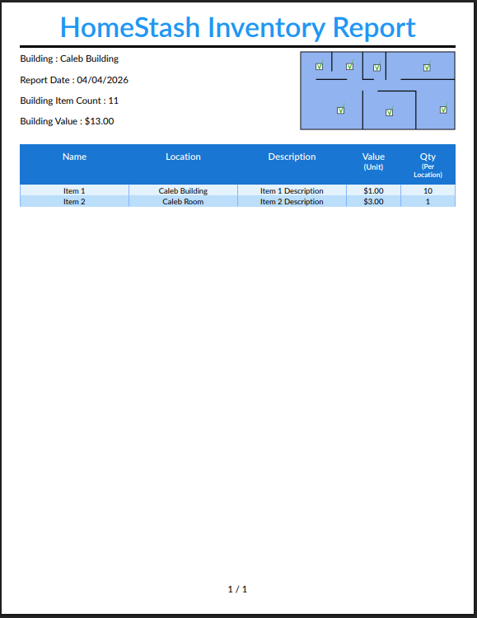

System Architecture
Project Home Stash is a standalone desktop application that runs entirely on the local machine of the user. It requires no external network or internet connection, and all processing and data generation occur locally. The application itself is a single executable file that is packaged in a folder with several supporting files and libraries. As a result, the executable can be run from anywhere on the local machine, provided it is in the same folder as all the required supporting files.
When the program runs, it reads from a JSON file that serves as long-term storage, which is contained in the package folder. All operations, including data entry, storage, and retrieval, are handled entirely within the application on the user's machine. The application also provides the ability to generate PDF reports, which are exported to a file path of the user's choosing on their local system.
Since Home Stash is a single-user, standalone application with no shared data access or external connections, record-locking is not applicable to this system.
The diagram below represents the interaction of the live application with the various application components in storage.
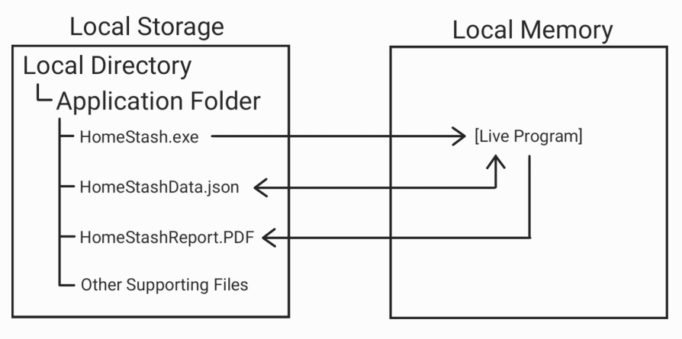

Source Code Structure
The source code for Project Home Stash is primarily segregated by front-end and back-end logic. This separation is implemented through the use of FrontEnd and BackEnd directories within the top-level project directory.
The code in the BackEnd directory is responsible for the core logic and algorithms that drive the application's functionality. The code in the FrontEnd directory is responsible for generating the graphical user interface (GUI) and facilitating user interaction with the system.
The following is a summary of the source code directories and their contents:
Code Directory
Directory | Usage
HomeStash | The top-level solution folder that houses all files needed to compile and run the program.
HomeStash\BackEnd | The back-end source code responsible for the core logic and functionality of the application.
HomeStash\BackEnd\DataContinuity | Handles data persistence, including reading from and writing to the JSON file used for long-term storage.
HomeStash\BackEnd\Enumerations | Enumeration definitions used throughout the application to represent fixed sets of named values.
HomeStash\BackEnd\ModelClasses | The core data model classes that represent the application's primary functionality and data.
HomeStash\BackEnd\ModelInterfaces | The interfaces that define contracts for the model classes enforce consistency and abstraction across the back end.
HomeStash\BackEnd\Reports | Logic for generating reports, including the creation and formatting of PDF output.
HomeStash\BackEnd\Utilities | Provides helper functions and reusable components used across the back end.
HomeStash\FrontEnd | The front-end source code responsible for the graphical user interface of the application.
HomeStash\FrontEnd\Controls | Custom UI controls for the Home Stash user interface.
HomeStash\FrontEnd\Controls\ UserControls | Custom user control inherited objects that are part of the interactive elements of the GUI.
HomeStash\FrontEnd\Controls\ Utilities | Specialized components that provide functionality not offered by the standard toolbox objects.
HomeStash\FrontEnd\Forms | The application's form definitions, which serve as the main windows presented to the user.
HomeStash\FrontEnd\Resources | Static assets used by the application, including images, icons, and other non-code files.
HomeStash\FrontEnd\Utilities | Helper functions and classes that support front-end operations and UI-related logic.
Highlighted rows indicate directories directly containing source code.

Executables

HomeStash (HomeStash.exe)
This is the sole executable for the project, providing the full functionality of the application.
When executed, the user is brought to the first screen of the application, and can fully navigate to any other portion of the application.

Code Architecture
Architecturally, Project Home Stash is split into three major components. These components are the front-end, the back-end, and the data store.
The back-end is solely responsible for all core program logic and functionality to manage the state of the program. This includes business logic validation and generating all relevant program objects, such as users, buildings, rooms, and items. Through these objects, the back-end manages the CRUD operations, ensuring a valid state for the itemized building inventories. Additionally, the back-end communicates with both the front-end and the data store. With the front-end, it provides program data and processes any CRUD requests the front-end generates. With the data store, the back-end provides serialized data in JSON format for long-term storage, and deserializes the stored data on startup to initialize live program values.
The front-end is solely responsible for generating the graphical user interface and managing valid interactions between the user and the back-end. This includes rendering all the forms and controls using the data provided from the back-end. Once the forms are created, the front-end displays these forms to the user who interacts with them and provides input. The front-end takes this input, performs input validation, and passes it to the back-end to progress the state of the program.
The data store is responsible for maintaining long-term persistence of all application data. It is implemented as a JSON file stored locally on the user’s machine. This file contains all users, buildings, rooms, and items in a hierarchical structure that mirrors the structure in the back-end. The data store itself does not perform any logic, but is accessed by the back-end, which is responsible for actively reading from and writing to it during program execution.
Internally, the majority of the code architecture reflects object-oriented programming principles. Most of the object design in all three components is interfaces, base classes, or inherited classes. For the front-end, all custom user-controls and forms are inherited classes that use the bases provided by Windows Forms. This structure allows the front-end to reuse all the functionality already in place, while also providing customized controls to meet the needs of the application. The main components of the back-end are all classes. These are the Model Class objects, such as the User, Building, Room, and Items. These objects maintain hierarchical relationships, where users contain buildings, buildings contain rooms, and rooms contain items. Additionally, buildings can directly contain items, and special items called containers can also contain items.
When a user takes some action on the front-end, such as adding an item, the following occurs internally. The front-end form performs input validation on the request and then passes it along to the back-end. The back-end performs business logic validation on the request, completes the action, and notifies the front-end that the action has been completed, which enables the front-end to visually update and reflect the change. Finally, when the front-end initiates a save request, the back-end serializes the data into the data store for data persistence.

Data Store
Project Home Stash uses a locally stored JSON file as the data store rather than a relational database.
This approach was chosen because the application's data structure is inherently hierarchical between users, buildings, rooms, and items. JSON's nested object and array structure naturally mirrors this hierarchy, making it a practical choice for data persistence in this application.
Below is a diagram illustrating the JSON structure used.

JSON as Simplified Tree View
User List []
└── User (Single Instance)
├── Username
└── BuildingList []
└── Building (Single Instance)
├── Name
├── Width
├── Height
├── CurrentStorage
│ └── StoredItems []
│ ├── Container (Single Instance)
│ │ ├── Name
│ │ ├── Description
│ │ ├── Value
│ │ ├── Quantity
│ │ └── StoredItems []
│ │ └── Item (Single Instance)
│ │ ├── Name
│ │ ├── Description
│ │ ├── Value
│ │ └── Quantity
│ └── Item (Single Instance)
│ ├── Name
│ ├── Description
│ ├── Value
│ └── Quantity
└── RoomList []
└── Room (Single Instance)
├── Name
├── Width
├── Height
├── CenterX
├── CenterY
├── RoomColor
└── CurrentStorage
└── StoredItems []
└── Item (Single Instance)
├── Name
├── Description
├── Value
└── Quantity
Generated Using: https://tree.nathanfriend.com/
The diagram shown above simplifies the JSON structure into an expanded tree view to provide visual clarity. Any JSON object that is a list will be followed by “[ ]”. Wherever there is a list, the object nested beneath it represents a single item in that list and is indicated by “(Single Instance)”. Any text representing a property will be a single line, while text representing an object includes nested elements beneath it to indicate its associated properties.
From this, we can see the hierarchical nature of the JSON with a list of users at the top level. Each user has a username and a list of buildings. Each building has a name, a width, and a height representing its physical dimensions, a direct storage object for items housed outside of any specific room, and a list of rooms. Each room has a name, width, and height, a center position represented by CenterX and CenterY, a color value, and its own storage object for items housed within it. Storage objects at both the building and room levels contain a list of items or containers. Containers and items share the same properties, which are name, description, value, and quantity. Additionally, containers have their own nested storage list, allowing containers to hold other items or containers recursively.

Views, Stored Procedures and User Defined Functions
This section does not apply to the data persistence approach taken for Project Home Stash. These features apply to a relational database management system, which this application does not use.

External Files & Data
Project Home Stash interacts with two external files during its execution.
The first external file is the JSON data file, detailed in the data store section above. This file is stored locally in the same application folder as the executable and serves as the data persistence component of the application. It is read at startup to populate the application with any saved data, and is written to whenever the user saves within the running application.
The second external file is the PDF report that the application generates. This file is stored wherever the user specifies during the report generation process. This file is strictly an output and is not read back into the application at any point.
Because Project Home Stash is a standalone application with no network or internet component, no security measures were implemented. Finally, the application does not utilize the Windows Registry for storing configuration or application data.

Programming Language | C#.NET
Both source code components of Project Home Stash, the front-end and the back-end, are written using C# in the .NET 8.0 framework. The back-end is implemented as a class library for the front-end to reference. The front-end is implemented as a Windows Forms desktop application.
Two external DLLs are used to support the functionality of the application. The first external DLL is QuestPDF.dll, which is created by QuestPDF, an open-source PDF generation tool. This DLL provides the functionality to programmatically create PDFs using live data instances. The second external DLL is ObjectListView2022NET.dll, which is provided by ObjectListView. This DLL is used to create the multi-column TreeListView that is in the top-down screen of the program.

Project Classes
Project Home Stash uses multiple classes and interfaces that are primarily segregated by front-end and back-end, and secondarily segregated by functional category. The project utilizes these classes:

BackEnd Data Continuity Classes
These classes serve to support data continuity between live application sessions.

Building Data Transfer Object | BuildingDTO.cs
The BuildingDTO class is a Data Transfer Object that represents a Building and its associated data in a structure compatible with the .NET System.Text.Json serializer. It serves as the intermediate structure between the live Building model object and the JSON data store, facilitating smooth serialization and deserialization of Building objects.

Item Data Transfer Object | ItemDTO.cs
The ItemDTO class is a Data Transfer Object that represents an Item and its associated data in a structure compatible with the .NET System.Text.Json serializer. It serves as the intermediate structure between the live item model object and the JSON data store, facilitating smooth serialization and deserialization of Item objects.

Room Data Transfer Object | RoomDTO.cs
The RoomDTO class is a Data Transfer Object that represents a Room and its associated data in a structure compatible with the .NET System.Text.Json serializer. It serves as the intermediate structure between the live Room model object and the JSON data store, facilitating smooth serialization and deserialization of Room objects.

RootManager Data Transfer Object | RootManagerDTO.cs
The RootManagerDTO class is a Data Transfer Object that represents a RootManager and its associated data in a structure compatible with the .NET System.Text.Json serializer. It serves as the intermediate structure between the live RootManager model object and the JSON data store, facilitating smooth serialization and deserialization of RootManager objects.

Storage Data Transfer Object | StorageDTO.cs
The StorageDTO class is a Data Transfer Object that represents a Storage and its associated data in a structure compatible with the .NET System.Text.Json serializer. It serves as the intermediate structure between the live Storage model object and the JSON data store, facilitating smooth serialization and deserialization of Storage objects.

User Data Transfer Object | UserDTO.cs
The UserDTO class is a Data Transfer Object that represents a User and its associated data in a structure compatible with the .NET System.Text.Json serializer. It serves as the intermediate structure between the live User model object and the JSON data store, facilitating smooth serialization and deserialization of User objects.

BackEnd Model Classes
These classes serve as the main data objects that drive the state and functionality of the program. They represent live data instances of the main logical components of the application.

Building Object | Building.cs
The Building class is a model object that represents a physical building within the application. In addition to basic descriptive properties and spatial properties, this class also contains two significant properties. The first is a list of Room objects representing the rooms in a building, and the second is a list of stored items, representing items stored directly in the building and not in a room. This object provides self-validation, ensuring the building's properties are valid, and system validation to ensure the rooms within the building are valid. Additionally, the Building class forwards events from its children and exposes its own events to provide notifications when changes occur within the building or its components.

Container Object | Container.cs
The Container class is a model object that inherits from the Item class and represents an item capable of storing other items within the application. In addition to basic descriptive properties, this class also contains a list of stored items, representing items stored directly within it. This object provides self-validation, ensuring the container’s properties are valid. Additionally, the container class forwards events from its children and exposes its own events to provide notifications when changes occur within the container or its components.

Item Object | Item.cs
The Item class is a model object that represents a basic item that is stored directly or indirectly within the building. It contains basic properties that are used to provide information about item characteristics that would be relevant to an itemized list. These include name, description, quantity, value, and location. This object provides self-validation, ensuring the item properties are valid. Additionally, the Item class exposes its own events to provide notifications when changes occur within it.

Room Object | Room.cs
The Room class is a model object that represents an individual room that exists within a specified building. In addition to basic descriptive properties, the Room class also stores spatial properties, including its center coordinates and dimensions to define its context within the building. This class also contains a list of stored items, representing items stored directly within it. This object provides self-validation, ensuring the room’s properties are valid. Additionally, the Room class forwards events from its children and exposes its own events to provide notifications when changes occur within the room or its components.

Root Object That Manages All Other BackEnd Objects | RootManager.cs
The RootManager class is the top-level backend class that serves as the starting point for the application’s hierarchy tree. A single RootManager instance serves as the consistent entry point for all front-end interactions with the back-end. While it does not represent a physical element in a home inventory, it serves as the central data source for all logical components of the application. This class maintains a list of user profiles and provides system validation to ensure the user profiles are valid. It also exposes events that notify the rest of the application when specific state changes occur within the program.

Storage Object | Storage.cs
The Storage class is a supporting model object that represents the storage element of any logical component within the application. Logical classes such as Buildings, Rooms, and Containers all implement storage by composition, each containing a Storage instance as an internal property. The Storage class is responsible for managing collections of stored items and containers, and the CRUD operations on items. It also provides system-level validation, ensuring that operations such as moving containers do not create invalid states. The Storage class also contains logic to recursively calculate the total item count and total value of all items within it. Finally, this class provides events to notify other elements of the program when changes occur within it.

User Object | User.cs
The User class is a model object that represents a user profile within the application. This class contains a list of buildings, representing all the buildings the user is managing. This object provides self-validation, ensuring the user’s properties are valid, and system validation to ensure the buildings are valid. Additionally, the User class exposes events to provide notifications when building-related changes occur.

BackEnd Model Interfaces
These interfaces serve as the contracts for the model classes and enforce consistency and abstraction across the back end.

Storage Interface | IStorage.cs
The IStorage interface defines the contract for storage behavior within the application. It specifies the operations required to manage collections of stored items and containers, including adding, modifying, moving, and removing items. It also defines methods for calculating aggregate values, such as total item count and total item value. Currently, the Storage class is the sole implementation of this interface. However, by programming against IStorage rather than the concrete Storage class, the back-end is designed to accommodate alternative storage implementations in future development without requiring structural changes.

Storage Holder Interface | IStorageHolder.cs
The IStorageHolder interface defines the contract for any object that contains storage within the application. It specifies the operations required to manage collections of stored items and containers, including adding, modifying, moving, and removing items. It also defines methods for calculating aggregate values, such as total item count and total item value. While the functionality defined in IStorageHolder is similar to that of IStorage, the two interfaces serve different roles. IStorage defines the behavior of the storage mechanism itself, and IStorageHolder defines the behavior of objects that contain storage. Currently, any objects that have storage, such as Buildings, Rooms, and Containers, implement the IStorageHolder Interface. This allows all three of the object types to be referenced in a single list, which allows storage holders to be treated polymorphically when managing item movement between different object types.

Stored Item Interface | IStored.cs
The IStored interface defines the contract for any object that can be stored within storage. It specifies the common set of properties all stored items must have, including name, description, value, quantity, and immediate parent. Currently, both Items and Containers implement the IStored interface, allowing both object types to be referenced in a single list, which allows polymorphic references when managing them.

BackEnd Report Classes
These classes serve to support on-demand report generation based on the current back-end model state.

Report Intermediary Object | ReportObject.cs
The ReportObject class is an intermediary class that sits between the BackEnd model classes and the ReportGenerator. It serves to consolidate the various formats and structures of the BackEnd model classes into a consistent format that the ReportGenerator can use. The properties it defines are those used by the report, which are name, location, description, value, and quantity.

BackEnd Utility Classes
These classes serve to provide helper functions and reusable components used across the back end.

Identification Manager | IDManager.cs
The IDManager static class is responsible for generating a new and unique ID number for every Item or Container that is generated. Currently, this class is not being used, however it is being kept in the source code in case future development requires the implementation of an ID property on any IStored objects.

FrontEnd Control Classes
These classes serve to provide Custom UI screens, forms, and controls for the Home Stash user interface.

Building Control| BuildingControl.cs
The BuildingControl class is responsible for rendering a visual representation of an individual back-end Building object and managing user interaction with it. It is a sub-component of the TopDownBuildingView control, providing the user with an interactive view of the building's live state. The control dynamically displays the building’s layout, including its dimensions, rooms, and a grid overlay used for spatial reference. It subscribes to back-end building events to remain synchronized with the current data, automatically updating the display when changes occur. Additionally, the BuildingControl manages user interaction by supporting actions such as view scaling and room selection, responding to user input, and providing visual feedback based on those interactions.

Building Control Visual Buffer| BuildingControlBuffer.cs
The BuildingControlBuffer class is a support class that serves as both a functional and visual wrapper for the BuildingControl class. It is responsible for rendering a visual padding around the building control and creating grid labels associated with the dimensions of each grid line in the BuildingControl. The control automatically resizes itself based on the BuildingControl, in order to maintain a consistent visual buffer throughout the entire user interaction with the BuildingControl.

Building Information Screen| BuildingInfo.cs
The BuildingInfo class is responsible for rendering an interactive screen used to capture, edit, and display building information. It provides input fields for building attributes such as name, width, and height. The control operates in two modes: add mode, in which all input fields are empty upon opening, and modify mode, in which the fields are pre-populated with the existing building's current properties. User actions are handled through confirm and cancel controls, allowing the entered data to either be passed along for processing or discarded.

Item Information Screen| ItemInfo.cs
The ItemInfo class is responsible for rendering an interactive screen used to capture, edit, and display item information. It provides input fields for item attributes such as name, description, type, value, quantity, and location. The control operates in two modes: add mode, in which all input fields are empty upon opening, and modify mode, in which the fields are pre-populated with the existing item’s current properties. User actions are handled through confirm and cancel controls, allowing the entered data to either be passed along for processing or discarded.

Room Control| RoomControl.cs
The RoomControl class is responsible for rendering a visual representation of an individual back-end Room object and managing user interaction with it. It is a sub-component of the BuildingControl control, providing the user with an interactive view of the room’s live state. The control dynamically displays the room’s name, dimensions spatially, item count, and item value. It subscribes to back-end room events to remain synchronized with the current data, automatically updating the display when changes occur. Additionally, the RoomControl manages user interactions by supporting actions such as clicking and providing visual feedback based on those interactions.

Room Information Screen| RoomInfo.cs
The RoomInfo class is responsible for rendering an interactive screen used to capture, edit, and display room information. It provides input fields for room attributes such as name, width, height, CenterX, CenterY, and color. The control operates in two modes: add mode, in which all input fields are empty upon opening, and modify mode, in which the fields are pre-populated with the existing room’s current properties. User actions are handled through confirm and cancel controls, allowing the entered data to either be passed along for processing or discarded.

Selection Screen| Selection.cs
The Selection class is responsible for rendering a list of selectable objects that the user can interact with. From this list of objects, the user is able to either select an object to advance the program’s state or perform CRUD operations on it. The selection control is modular in that it supports listing multiple types of objects instead of a specific object type. This is accomplished through the use of an AdapterSelection object, which takes various objects as input and produces a consistent output for the Selection control to read from. The control dynamically populates its list based on the adapter's data and provides visual feedback by highlighting the currently selected item. It exposes select, add, modify, and delete events that the parent form handles to process the user's requested action.

Top Down Building View Screen| TopDownBuildingView.cs
The TopDownBuildingView class is the primary screen the user will interact with during program execution, serving as the main interface for managing a building's rooms and inventory. Its purpose is to provide a 2D top-down view of the building, giving the user a visual representation of their home inventory. It is composed of two main panels: a camera panel on the left that houses the scrollable and zoomable BuildingControlBuffer, and a panel on the right that alternates between displaying a hierarchical TreeListView of the building's contents and any information screens used to add or modify rooms and items. This split design enables continuous interaction between the visual floor plan and the inventory management controls. User interaction is primarily managed through a toolbar, which provides controls for adjusting the building view, modifying building properties, and performing CRUD operations on rooms and items. When a room or item is selected, either through the floor plan or the TreeListView, the toolbar updates contextually to enable the relevant actions. The control subscribes to back-end events to keep both the floor plan and TreeListView synchronized with the current building data.

User Information Screen| UserInfo.cs
The UserInfo class is responsible for rendering an interactive screen used to capture, edit, and display user information. It provides an input field for the username attribute. The control operates in two modes: add mode, in which the input field is empty upon opening, and modify mode, in which the field is pre-populated with the existing user’s username. User actions are handled through confirm and cancel controls, allowing the entered data to either be passed along for processing or discarded.

Toolstrip Numeric Up Down Control| ToolStripNumericUpDown.cs
The ToolStripNumericUpDown class is a custom ToolStrip control that is a wrapper for the standard Windows Forms NumericUpDown in order to make it usable on ToolStrip containers. Since the standard NumericUpDown control cannot be placed directly within a ToolStrip, this class serves as an adapter, allowing it to be placed in a ToolStrip like any native ToolStrip item.

Transparent Panel Control| TransparentPanel.cs
The TransparentPanel class is a custom UI control that provides a semi-transparent overlay within the application. It is used in the application as a blocking panel that is placed over the camera view to visually dim and prevent interaction with the floor plan while an add or modify operation is in progress. The opacity level is expressed as a percentage from 0 to 100, allowing the degree of transparency to be adjusted as needed. This class is based on a community solution sourced from Stack Overflow, with the specific source detailed in the source code.

FrontEnd Form Classes
This class serves to provide a custom Windows Form that serves as the framework from which the other screens are dynamically displayed.

Dashboard Form| Dashboard.cs
The Dashboard form is the main application form that serves as the top-level container for all screens and controls within the application. On startup, it initializes a RootManagerInstance, which serves as the top-level back-end object that persists throughout the entire program execution. The Dashboard contains a viewport panel that dynamically displays different controls based on the current state of the program, including selection screens, info forms, and the TopDownBuildingView. Navigation between screens is facilitated through a menu bar, which contextually enables and disables options based on the current program state. Additionally, the menu bar provides the save and report functionality described above. Finally, it also handles all events raised by its child controls, translating user actions into back-end calls.

FrontEnd Utilities Classes
These classes serve as helpers or adapters that support the operations of the other front-end classes in the application.

Selection Control Adapter | AdapterSelection.cs
The AdapterSelection class is responsible for converting a source list of back-end objects into a standardized list that can be displayed in the Selection control. It does this by taking the source list and producing a list of AdapterSelectionItem objects as an output. The list of AdapterSelectionItems serves as consistent input that can be used by the Selection control, so that it is not dependent on a specific object type to function. The adapter subscribes to the appropriate back-end events based on the source object type, and notifies the Selection control when the source data changes so the displayed list remains synchronized with the current back-end state.

Selection Control Adapter Line Item | AdapterSelectionItem.cs
The AdapterSelectionItem class represents a single item in a Selection control’s list. It stores a test attribute used for the visual representation, and a value attribute that is the underlying source object. Each AdapterSelectionItem is created with the display text and its corresponding back-end object, allowing the Selection control to consistently generate lists based on different source objects.

Combo Box Line Item | ComboBoxLineItem.cs
The ComboBoxLineItem class represents a single item within a ComboBox control and provides a standardized way to display and reference IStorageHolder objects. Each item stores a text attribute and a tag attribute, which references the underlying IStorageHolder. The class determines the display text based on the type of the associated IStorageHolder, supporting Building, Room, and Container objects. This enables consistent rendering and selection behavior in ComboBox controls, while maintaining a direct link to the back-end data.

Project Modules
Project Home Stash uses several instances of stateless procedural-based code to create desired functionality. This takes the form of static classes and enumerations. The project utilizes these examples of stateless procedural code:

BackEnd Data Continuity Classes
These classes serve to support data continuity between live application sessions.

DTO To Live Instance Converter | Converter.cs
The Converter class is responsible for constructing live class model objects from their DTO counterparts. This class uses a top-level RootManagerDTO object as the source and generates a RootManager instance used by the program. Both the source and output are structured hierarchically and contain all the child objects.

Serialization And Deserialization | DataContinuityController.cs
The DataContinuityController class is responsible for serializing live data and deserializing stored data. The target object is the RootManager instance, so the process occurs once at the top level of the object hierarchy. When serializing data, the live RootManager instance is serialized directly into JSON. When deserializing, the stored JSON is deserialized into a RootManagerDTO, which the Converter class then converts into a live RootManager instance.

BackEnd Enumerations
These enumerations provide fixed sets of named values used throughout the application.

Stored Type Enumeration List| EnumStoredType.cs
The StoredItemType enumeration defines the two possible types of stored items within the application. The Item value represents a standard item with no nested storage, and the Container value represents an item capable of holding other items or containers within its own storage.

BackEnd Report Classes
These classes serve to support on-demand report generation based on the current back-end model state.

Itemized List Report Generator | ReportGenerator.cs
The ReportGenerator is responsible for generating a PDF of the itemized inventory for a single building based on the current state of the application. The report does not directly use the class model objects, but instead relies on the intermediate ReportObject class to provide all the relevant information in a consistent format. With the ReportObjects, the ReportGenerator generates a PDF through the QuestPDF library. The generated PDF consists of a header containing building summary information such as name, report date, total item count, and total value, followed by a table where each row represents an item and the columns display its name, location, description, value, and quantity. Once the PDF is generated, the system saves it in the location specified by the user.

FrontEnd Utilities Classes
These classes serve as helpers or adapters that support the operations of the other front-end classes in the application.

Form Type Enumeration List| EnumFormType.cs
The EnumFormType enumeration defines the two possible types of modes the “info” forms can execute in. The Add value represents an info form executing in add mode, which is to create a new object, and the Modify value represents an info form executing in modify mode, which is to edit an existing object.

Program Start and End Flow
The program execution begins when the user clicks on the HomeStash.exe icon, launching the executable.
The entry point for the application is the static Program class, which invokes its static Main method. Within Main, the application configuration settings are initialized, and Application.Run() is called with a new Dashboard instance, starting the Windows Forms message loop and displaying the Dashboard form.
When the Dashboard initializes, it creates a RootManager instance through the DataContinuityController static class. The RootManager serves as the top-level back-end object that contains all live program data during execution. If “HomeStashData.json” exists in the same folder as the executable, the DataContinuityController deserializes the data from this file to pre-populate the RootManager. If that file doesn’t exist, the DataContinuityController creates an empty instance of the RootManager.
After object initialization, the Dashboard initializes visuals and passes control to the user. At this point, the program cycles through a loop of user input, front-end processing, back-end processing, and front-end visual updates. This continues until the user closes the program.
Currently, no automatic save or customized shutdown procedure is implemented, so when the user clicks to exit the program, control is returned to the program. The Dashboard form is disposed of, and the Windows Forms message loop terminates, ending the program.
See below for Start/End diagram:
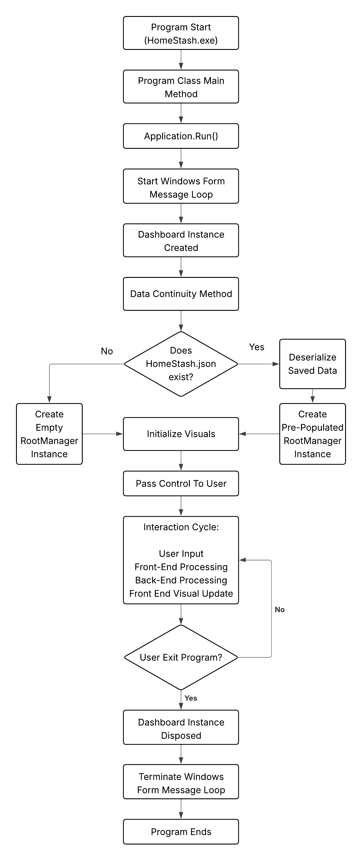

Summary
Project Home Stash is a standalone desktop application built in C# using the .NET 8.0 framework with the Windows Forms (WinForms) project template. The purpose of the application is to provide users with the ability to create and manage a digital inventory of their items. A defining feature of the system is its integration of inventory management with a visual layout tool, allowing users to identify the location of items within a building through an interactive 2D floor plan.
Typical user interactions involve profile and building selection, CRUD operations on inventory objects, inventory management through the top-down visual interface, and manual saving and PDF report generation. These interactions are facilitated through three primary screen types: the selection screens for navigating users and buildings, the object info screens for entering and editing individual data, and the TopDownBuildingView, which serves as the main program interface for inventory management. All inventory data, including users, buildings, rooms, items, and containers, is organized hierarchically and managed through a consistent set of CRUD operations. The application also supports manual data persistence through saving and provides on-demand PDF report generation, producing an itemized inventory list for the active building.
Architecturally, the program is divided into three distinct components: the front-end, the back-end, and the data store. The front-end is responsible for rendering the graphical user interface and managing user interaction, while the back-end handles business logic, validation, and data management. The data store, implemented as a JSON file, provides persistence between application sessions. The source code folder structure reflects this separation, with a primary distinction between front-end and back-end directories and sub-folders representing specialized functionality within each. The JSON data store mirrors the live data hierarchy of users, buildings, rooms, and items, providing a permanent reflection of the live data that can be recalled later.

APPENDIX A (TESTING, MAINTENANCE, AND DEPLOYMENT)

Testing Plan
Testing for Project Home Stash followed a strategy of incremental unit and integration testing. Testing and debugging occurred alongside initial implementation and development rather than as a separate, final phase.
During development, individual components were tested immediately after implementation through manual execution and debugging. Examples include validating user interface behavior, verifying correct data handling, and ensuring that back-end operations such as CRUD functionality produced the expected results. Any issues identified during this phase were resolved before proceeding to additional development.
As components were combined, integration testing was performed to ensure that interactions between the individual components functioned as intended. This included both internal method interactions within the same project and external interactions between public methods across projects. Any interactions that did not function as intended were corrected before further integration or development.
System-level testing was conducted by running the full application and executing typical user scenarios, including creating users, managing buildings, adding rooms and items, saving data, and generating reports. This ensured that all major features operated correctly within the complete application environment.
This iterative testing process provided continuous validation of functionality throughout development, ensuring correct system behavior at each stage. It also improved development efficiency by narrowing the scope of issues as they arose, rather than requiring full-system debugging at the end of development.

Deployment Plan
The deployment strategy for Project Home Stash follows the timeline dictated by the course, with a target deployment date of 04/19/2026. All development and feature implementation decisions are evaluated against this deadline. As a result, not all desired features are feasible within the given timeframe, requiring deployment to occur in phases. To address this, three development phases were defined:
Phase 1 - Core MVP (Project Requirement):
- Complete backend data model (Item, Storage, Container, Room, Building, User, RootManager)
- JSON persistence (save/load functionality)
- Basic Windows Forms UI (Add/Edit/View items and rooms)
- 2D map visualization (view-only, room selection)
- Basic item list display sorted by room
- Simple PDF export (text-based inventory list)

Phase 2 - Enhanced Features:
- Drag-and-drop room positioning on the map
- Room resizing via mouse
- Visual reports (charts/graphs)
- Advanced UI polish and accessibility
- Zoom/pan controls on the map

Phase 3 - Quality of Life:
- Image attachment to items
- Advanced search and filtering
- Category management
For Phase 1, the deployment strategy is to complete implementation and debugging by the target date. Once development is finalized, the build and release process outlined in Appendix B is followed to package and distribute the application.
For Phase 2 and Phase 3, no fixed release dates are defined. These phases represent future enhancements that may be developed incrementally. Any subsequent releases will follow the same build and release process described in Appendix B.

Maintenance Plan
Looking forward, maintenance for Project Home Stash will follow a passive, feedback-driven approach rather than a fixed or scheduled maintenance cycle. Updates to the application will be made as needed based on user feedback, identified issues, or opportunities for improvement.
Rather than implementing proactive or continuous development, maintenance efforts will focus on resolving defects, improving usability, and addressing any functionality issues that arise during real-world use. When updates are required, changes will be developed, tested, and deployed following the build and release process outlined in Appendix B.

APPENDIX B (BUILD AND RELEASE PROCESS)
The build and release process for an update starts by creating a new “UpdateBranch” based on the current main branch of the source code. Once the branch is created, the developer makes the desired changes within this branch. This step includes the cyclical process of refactoring, testing, and debugging until the updated program produces the desired behavior without error.
Once development is complete, the developer pushes the UpdateBranch to the HomeStash repository using Git commands and creates a pull request for review. The pull request targets the main branch for merging. After the pull request is reviewed and approved, the UpdateBranch is merged into the main branch, and any merge conflicts that arise are resolved. Following a successful merge, the UpdateBranch can be deleted, and the source code is fully updated.
The next step is to refresh the main branch in the local development environment and compile the program using the Release configuration. Once the build is successful, the updated executable and its supporting files are packaged together. These supporting files include the JSON data file (if applicable), required DLLs such as QuestPDF and ObjectListView, and any resource files used by the application. The executable must remain in the same directory as these dependencies to function correctly.
The final step in the release process is to create a new release on GitHub using the updated main branch. This release includes a zipped folder containing the compiled build. Users can download this zip file to access the updated version of the program. An important consideration during the update process is that users must manually migrate their “HomeStashData.json” file to the new folder to preserve their existing data.

APPENDIX C (CLIENT INSTALLATION INSTRUCTIONS)
Preparation for the use of Project Home Stash is minimal. The first step the user must take is to ensure that the .NET 8.0 runtime is installed on the system. If it is not installed, the user must navigate to the official Microsoft website and download the required runtime. This process is straightforward; when attempting to run the application without .NET 8.0 installed, the user will receive a prompt indicating that the runtime is required, along with a link to download it. If this message appears, the user only needs to follow the provided link, download .NET 8.0, and install the runtime.
Aside from ensuring that the system has .NET 8.0 installed, no additional preparation is required. The user downloads the ZIP file from the repository, extracts the contents to a desired location on the system, then navigates to HomeStash.exe and runs the program.
If the user has an existing HomeStashData.json file from a previous version, it must be manually copied into the same directory as the new executable to preserve saved data. If no such file exists, the application will automatically create a new data file upon saving.
Once these steps are completed, the application is ready for use.

APPENDIX D (DEVELOPER SETUP INSTRUCTIONS)
To set up a local environment to work on the code, the first step is to install an IDE capable of supporting C# and .NET desktop development. Additionally, the developer must ensure that the .NET 8.0 SDK is installed on the system.
Once the appropriate IDE and runtime SDK are installed, the developer must navigate to the project source code on the GitHub repository and either fork the repository, download a local copy, or clone it. This provides access to the full source code. After obtaining the code, the developer must ensure that all required dependencies are included. In Visual Studio, this is handled automatically through the attached NuGet packages. If dependencies need to be added manually, the developer must include the ObjectListView2022NET.dll and QuestPDF.dll files.
After completing these steps, the development environment is fully configured, and the developer can begin working on the source code.

